**PDD – Process Definition Document**

Cowen – IT 2-Email Summary Database PDD



**Document Control Information**

|  |  |
| --- | --- |
| Document Name | Process Definition Document (PDD) |
| Project Name | IT 2- Email Summary Database PDD |
| Client | Cowen Inc. |
| Document Author | Maggy Kozman, Rishabh Bansal, Pooja Jindal |
| Document Version | **1.3** |
| Status | Draft |
| Architecture Approval | Chandrasekhar Siriguppa |
| Dev. Manager Approval | Chandrasekhar Siriguppa |
| Client Document Approver | Yin Chow |
| Date Released | 11/04/2020 |

**Document History**

|  |  |  |  |  |
| --- | --- | --- | --- | --- |
| Review tracking | | | | |
| Revision | **Description** | **Name** | **Role** | **Date** |
| v1 | Initial draft | Deloitte Team:  Maggy Kozman, ARA Senior; Rishabh Bansal, ARA Staff | Process Analysts Team | 11/04/2020 |
| v2 | Draft Review | Deloitte Team:  Cameron Andriola, ARA Manager;  Kirti Parakh, ARA Senior Manager | Process Analyst Team – Review | 11/04/2020 |
| v3 | Client Review | Cowen Team:  Yin Chow  Process Owner | Business Process Owner Team- Review | 2/18/2021 |

Table of Contents

1. Executive Summary and Purpose 4

2. Team Structure 5

3. Process Documentation 6

3.1 Systems in Scope 6

3.2 Target Applications 6

3.3 Process Videos 6

3.4 Process in Scope 7

3.5 Templates and Taxonomy 7

3.6 Assumptions 8

3.7 Operational Constraints 8

4. Process Description 9

4.1 Process Overview 9

4.2 Process Flow Diagram 11

4.3 Detailed step by step description of the process (with screenshots) 12

4.3.1.1 Access the Outlook desktop application

4.3.1.2 Type the specific sender name in the search bar to obtain the list of mails received from vendor

4.3.1.3 The bot will then identify category on the basis of subject of the mail

4.3.1.4 Bot will pull the required information (i.e. Common Fields and Variable Fields) from email based on different category which is shown below

4.3.3.1 Bot will summarised all the information in Email Summary database so that concerned department conduct investigation of the error

4.4 Service Level Agreements 25

5. Referrals and Exceptions 26

5.1 Human in the Loop Consideration 26

5.2 Business Exception 26

5.3 Technical Exception 26

6. Risk Controls 27

7. Business Continuity 28

7.1 Physical workforce unavailability 28

7.2 Virtual workforce unavailability 28

7.3 Target application unavailability 28

8. Change Requests 29

9. Non-Functional Requirements 30

**Executive Summary and Purpose**

The purpose of this document is to synthesize the detailed functional requirements to automate the IT Email Summary process. The document describes the current state and future state process flows, detailed step-by-step actions, and transitions. This document also contains the application access specifications and technical system/application requirements. This document serves as a blueprint for functional development. On an ongoing basis, the document will reflect any approved changes made to the automation.

Cowen Inc. is a multinational independent Investment Banking and Financial Services firm that has two primary business segments: 1) The Operating Company and 2) Asset Company. The Operating Company’s Investment Banking service provides numerous prime brokerage services in several different industries. The Asset Company performs investment management over the Company’s private and actively managed alternative investment products.

The process within the scope of automation below is performed by the Vendor Support team. Daily the support team receives the status reports generated from different applications providing the information on the number of records/messages/transactions processed, messages in error, or messages not processed. All emails are analyzed by the Support team to identify further actions to be taken based on the status of emails.

The Purpose and High-Level Design section focuses on the current state of the process, required inputs, and the keystroke-level, step-by-step analysis stating the actions. The Detailed Design section further encompasses the hardware, software, and infrastructure requirements to achieve the solution.

1. **Team Structure**

|  |  |  |
| --- | --- | --- |
| Name | Role | Email |
| **Deloitte Contact:** | | |
| Kirti Parakh | Process Analyst Senior Manager | [kirtiparakh@deloitte.com](mailto:kirtiparakh@deloitte.com) |
| Cameron Andriola | Process Analyst Manager | [candriola@deloitte.com](mailto:candriola@deloitte.com) |
| Maggy Kozman | Process Analyst Senior | [mkozman@deloitte.com](mailto:mkozman@deloitte.com) |
| Chandrasekhar Siriguppa | Architect & Manager | [csiriguppa@deloitte.com](mailto:csiriguppa@deloitte.com) |
| Venkatesh, Madipadiga | Developer | madvenkatesh@deloitte.com |
| Rahul, Ari | Quality Analyst | arahul@deloitte.com |
| Gopi Yalakanti | Infrastructure Specialist/Architect | [gyalakanti@deloitte.com](mailto:gyalakanti@deloitte.com) |
| **Cowen Contact:** | | |
| Nadine Haidar | Managing Director | [Nadine.Haidar@cowen.com](mailto:Nadine.Haidar@cowen.com) |
| Jose Dias | Associate | [Jose.Dias@cowen.com](mailto:Jose.Dias@cowen.com) |
| Anthony Carbonara | Managing Director | [Anthony.Carbonara@cowen.com](mailto:Anthony.Carbonara@cowen.com) |
| Yin Chow | Process Owner | [Yin.Chow@cowen.com](mailto:Yin.Chow@cowen.com) |
| Matt Tittler | IT Infrastructure | Matt.Tittler@cowen.com |
| Jose Dias | IT Access | Jose.Dias@cowen.com |

1. **Process Documentation**

Bot will execute the following sub-steps for preparing the IT- Email Summary Database.

3.1 Systems in Scope

The systems in scope for this automation are listed and described below:

* **Microsoft Outlook**: The summary of the issues reported under each application is received via outlook, from their specific vendors
* **SQL Database**: the bot will log relevant information summarized from IT alert emails into the SQL DB.
  1. Target Applications

The target applications Corporate Access Report Bot will interface with are described below:

|  |  |  |  |  |
| --- | --- | --- | --- | --- |
| ID | Automation Enabler/Application | Description | Type of Access | 3rd Party Consent Considerations |
| 1 | AD Account (Relevant Domain) | VM for Dev Logins | Admin | N/A - internal |
| 2 | MS Outlook | Outlook Access to send/receive mails  Bot-ITAlertDash@cowen.com | Read/Write  Send/Receive | N/A – internal |
| 3 | SQL Database | SQL Database access and SQL query are required for summarizing the data.  DEV server: DBDEV02  DB name: RPA  Table: TradeProcessMonitor  PROD Server: DBPROD01  DB name: RPA  Table: TradeProcessMon | Read/write | N/A- internal |
| 4 | Excel Application | To prepare final summary file | Read/write | N/A- internal |

* 1. Process Videos

The following video of the current state process were recorded as performed by the Process SMEs:

[IT-Email Summary Dashbard.mp4](https://teams.microsoft.com/_#/mp4/viewer/customspo/https:~2F~2Famedeloitte.sharepoint.com~2Fsites~2FCowenRPA~2FShared%20Documents~2FPDD~2FWave%202%20Use%20Cases~2FIT-%20Email%20Summary%20Dashboard~2F1%20Recordings%20and%20Support~2FIT%202%20-%20Email%20Summary%20Dashboard.mp4?threadId=19:f2d7c9c55a9b4481ba51a89fc3c1c673@thread.tacv2&baseUrl=https:~2F~2Famedeloitte.sharepoint.com~2Fsites~2FCowenRPA&fileId=FE428E83-922B-4E90-8E7D-3D4798DEECC9&ctx=custom-spo&viewerAction=view)

* 1. Process in Scope
* Access Outlook and, search for the vendors identified like Fidessa, Workday, and others for the purpose of creating IT Summary in Cowen’s database
* Emails with Success will be summarized and logged into SQL DB Table TradeProcessMonitor
* Emails with failure/exceptions will be forwarded to Manual inbox folder
* Emails for certain out of scope will be forwarded to OutOfScope folder so that teams for further investigation
  1. Templates and Taxonomy

|  |  |
| --- | --- |
| **Automation Input** | **Description** |
| Outlook | Structured and internally generated emails from specific vendors showing error or success status. |
| In Scope Emails |  |

|  |  |
| --- | --- |
| **Automation Output** | **Description** |
| Database and email notifications | Categories of emails showing error/success status and relevant fields for each category will be logged into SQL DB and bot will forward certain failure emails to respective groups. |
| Output file (logged into SQL DB) |  |
| Daily routine reporting email |  |
| Exception email sample | This email will be created if there are any business or technical exceptions that are detailed to the process owners in the following format. |

* 1. Assumptions
* No expected changes to websites, applications or databases in scope for the process
* No OCR
* All enablers will be completed before development/testing as specified above.
* All test data required will be made available by Cowen to the implementation team promptly after receiving the test plan
* Process mapping and step-by-step details are provided by Cowen to document in PDD accurately to reflect process requirements
* Process Owners and Subject Matters have reviewed all sections of the PDD, including exceptions, in detail before sign-off to confirm accuracy and completion of process design
  1. Operational Constraints

This section is used to describe the automation’s planned schedule timings, the volume, and a daily report format that summarizes the automation activities.

**Scheduled Time:**

The bot is scheduled to run 24 hours Sunday- Friday at @5pm EST

**Volume:**

There are no volume considerations applicable to this automation as it’s not expected to present overload or system constraints. Additionally, the business user has not experienced any system constraints either in terms of volume. Please note that there is a minimum of ~100 messages total for all categories per day and could run up to several hundred messages or thousand messages as some are depending on what clients are sending in and the status of the systems.

**Report Format:**

Refer to automation output section above for the summary of the automation’s activities for database logging summary of status for user to review.

1. **Process Description**

**The following table documents the step-by-step actions for the bot design, as well as screenshots for reference purposes:**

2. 1. Process Overview

The bot will follow the following main steps to access outlook and create the dashboard displaying the categories of mails showing errors and successful status with number of records processed and number of records that are failed and successful.

Step 1

* + Access the outlook desktop application.
  + Bot will identify based on specific sender name, email subject in the search bar to obtain the list of emails received from sender (*note: bot will search for the sender name NOT the sender email address*)
  + Bot will pull the email subject line to be extracted for the database which shows vendor name, vendor code, instrument number, date, and any other relevant fields outlined in section 3.5.
  + Bot will then identify category based on 1. subject of the email, 2. sender name, and 3. Fields specified in the Output file attached in section 3.5.
  + Pull the details of total number of records processed and number of records successfully loaded to be displayed on SQL DB Table (TradeProcessMonitor).

Step 2

* + The bot will then identify and pull the Status (Unsuccessful/ Successful) from the email for different category.
  + Bot will pull required fields (Common/Variable) from email for different category.

Step 3

* + Bot will summarize the information gathered from email and log into the SQL DB Table (TradeProcessMonitor).

Step 4

* + Bot will forward certain failure emails (outlined in the “output file” section 3.5) to TradeProcessMon@cowen.com for further investigation.

Step 5

Bot will send a status summary email at 5 PM ET notifying [TradeProcessMon@cowen.com](mailto:TradeProcessMon@cowen.com) that it ran successfully. The Bot will move OutofScope & Exception emails to respective OutOfScope, Exception Mailbox.Please note that the bot will notify [TradeProcessMon@cowen.com](mailto:TradeProcessMon@cowen.com) immediately if it encounters any technical and/or business exceptions listed in section 5 “Referrals and Exceptions” below.

4.2 Process Flow Diagram

[IT-Email Summary Dashbard.mp4](https://teams.microsoft.com/_#/mp4/viewer/customspo/https:~2F~2Famedeloitte.sharepoint.com~2Fsites~2FCowenRPA~2FShared%20Documents~2FPDD~2FWave%202%20Use%20Cases~2FIT-%20Email%20Summary%20Dashboard~2F1%20Recordings%20and%20Support~2FIT%202%20-%20Email%20Summary%20Dashboard.mp4?threadId=19:f2d7c9c55a9b4481ba51a89fc3c1c673@thread.tacv2&baseUrl=https:~2F~2Famedeloitte.sharepoint.com~2Fsites~2FCowenRPA&fileId=FE428E83-922B-4E90-8E7D-3D4798DEECC9&ctx=custom-spo&viewerAction=view)



* 1. Detailed step by step description of the process (with screenshots)

4.3.1.1 Step-1 - Access the Outlook desktop application.

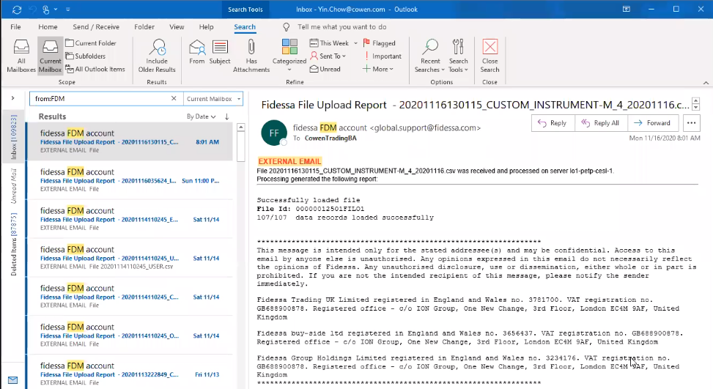

* + - 1. Type the specific sender name in the search bar to obtain the list of mails received from vendor.

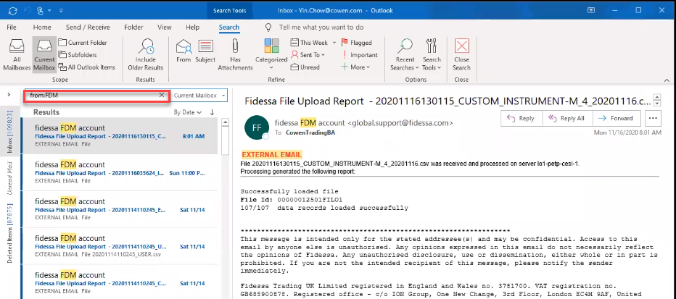

* + - 1. The bot will then identify the category based on subject of the e-mail. (Example 1)  
           
         - Below is an example of a category

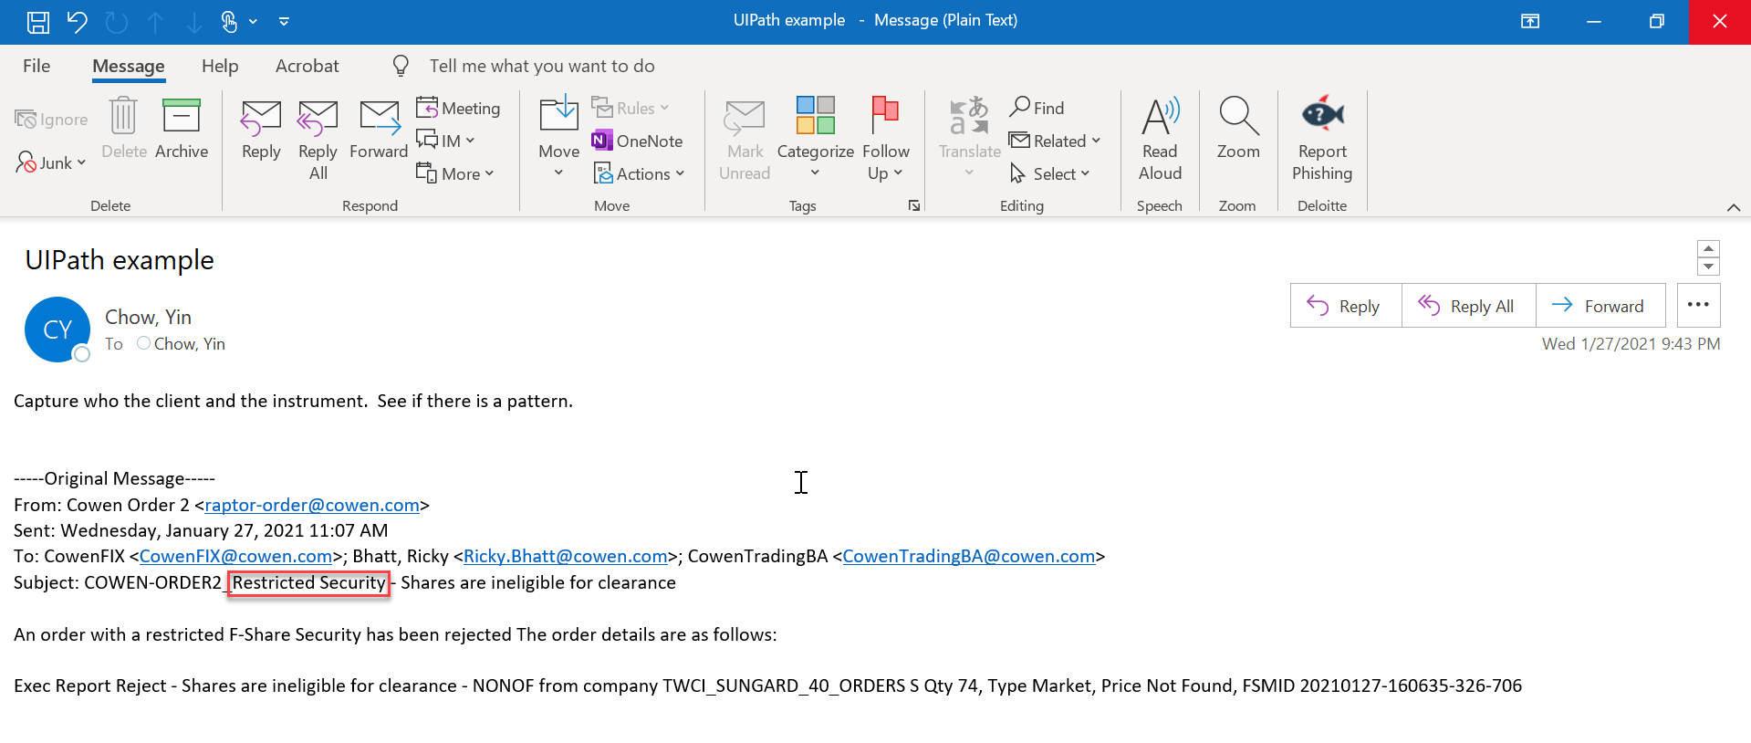

* + 1. Step-2 Bot will pull the required information (i.e. Common Fields and Variable Fields) from email based on different category which is shown below:

Bot will check specific word in the email to detemine whether email and update status column in excel report as Unscucessfull (Key word: Unsuccessfully/Ineligible) or Successful (Key word: successfully/eligible).

***Note***: refer to the ”Output File” in section 3.5 for a complete list of keywords for the sucess/failure emails.

**- Below is an example of unsuccessful message (Example 1)**

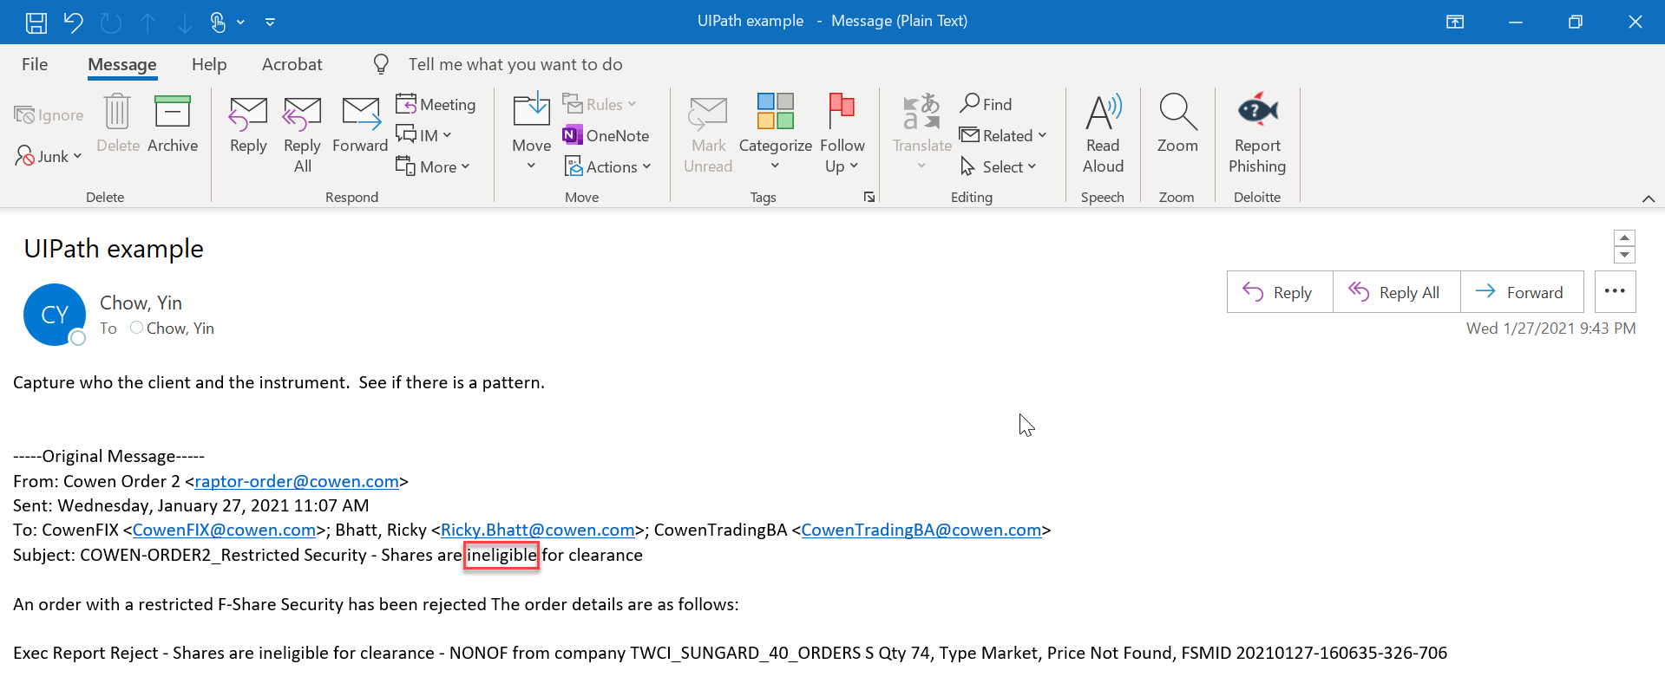

**- Below is an example of successful message (Example 25)**

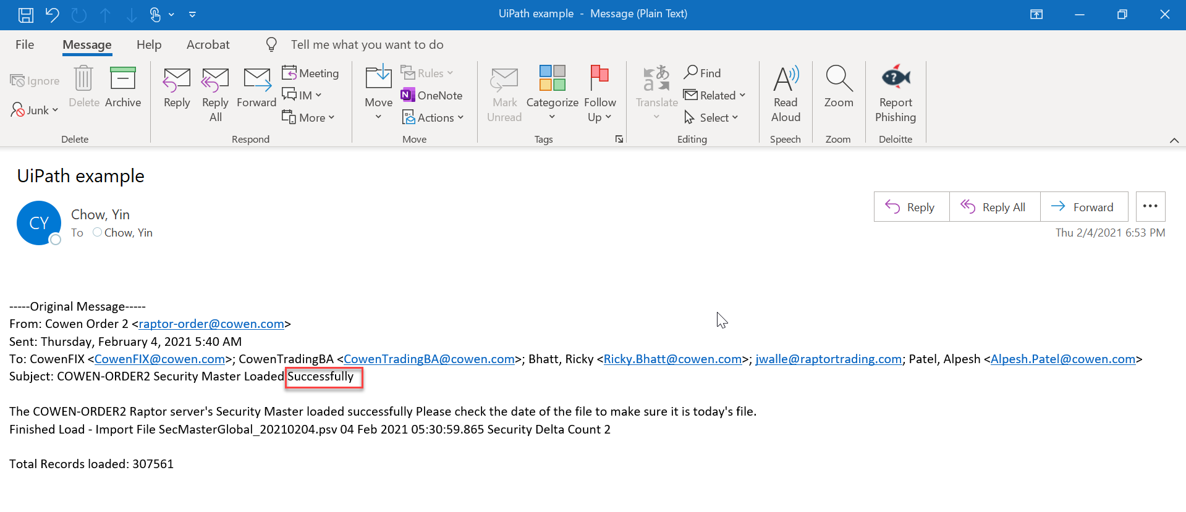

### Category 1: Log to DB: Email out to designated team to follow up

**Sender Name: Cowen Order 2 (Example 1)**

**Common Fields**

* **Sender Name:** Copy the text before less than sign (<) from “From” line in email and paste it in the “Sender Name” column of Email Summary Dashboard Excel (Cowen Order 2)
* **Sender Email:** Copy the text between sign (<>) from “From” line in email and paste it in the “Sender Email” column of Email Summary Dashboard Excel (raptor-order@cowen.com)
* **Email Date:** Copy the text from “Sent” line in email and paste it in the “Email Date” column of Email Summary Dashboard Excel.
* **Email Time:** Capture the time from “Sent” line in email and paste it in “Email Time” column Email Summary Dashboard Excel.
* **Subject**: Copy the text after semi colon (:) from “Subject” line and paste it in “Subject” column of Email Summary Dashboard Excel.

**- Refer to the screenshot of the email below (Example 1):**

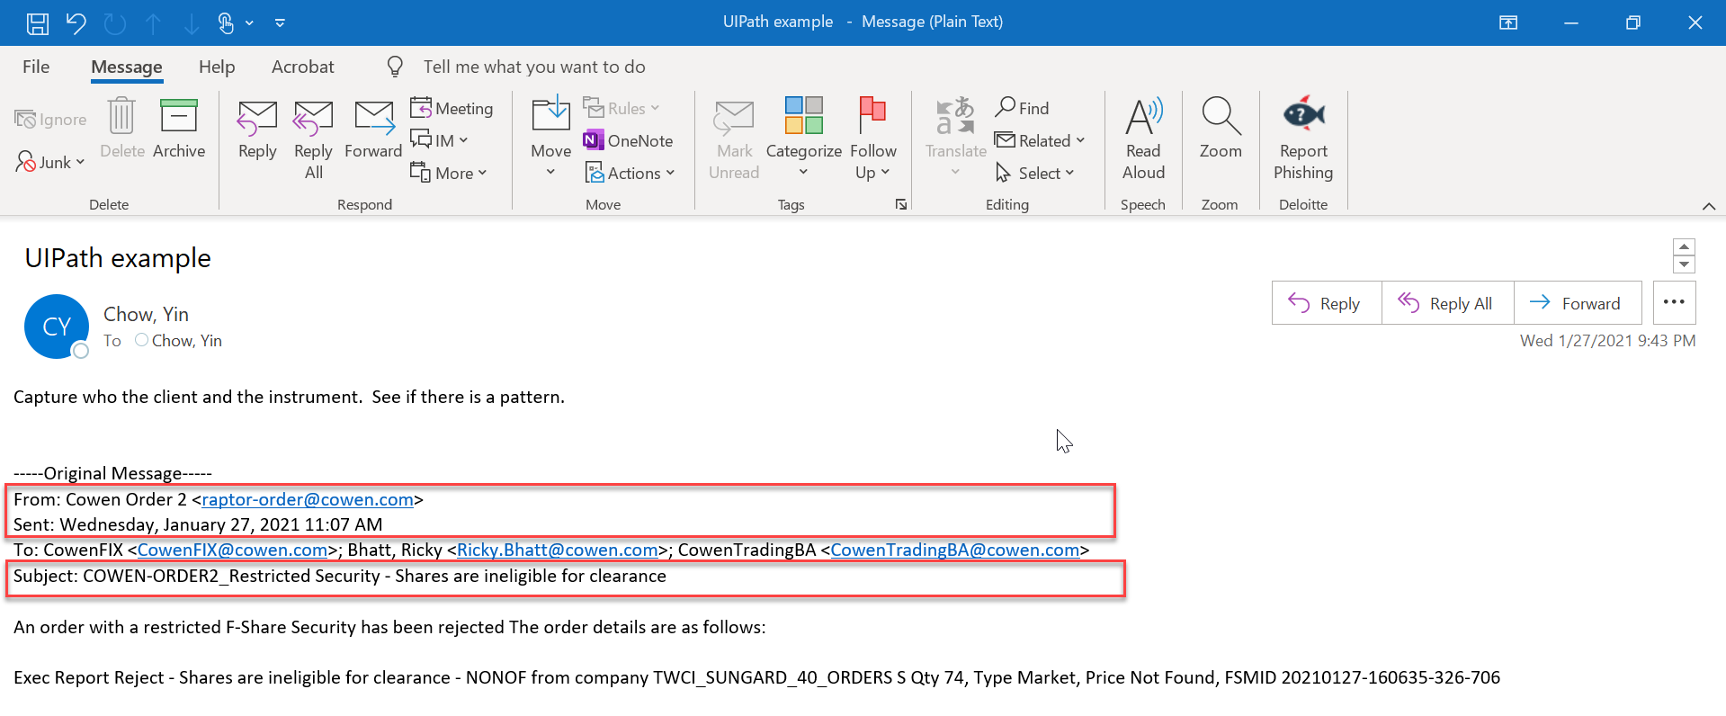

**Variable Fields**

* **Company mnemonic:** Copy text (“NONOF”) after “Shares are ineligible for clearance” from the last line of email body and paste it in the “Company mnemonic” column of Email Summary Dashboard Excel.
* **Company**: Copy text (“TWCI_SUNGARD_40_”) after word “company” from the last line of email body and paste in the “Symbol ID” column of Email Summary Dashboard Excel.
* **QTY:** Copy number (“74”) after word “QTY” from the last line of email body and paste in the “QTY” column of Email Summary Dashboard Excel.
* **Type:** Copy text (“Market”) after word “Type” from the last line of email body and paste in the “Type” column of Email Summary Dashboard Excel.
* **Price:** Copy text (“Not Found”) after word “Price” from the last line of email body and paste in the “Price” column of Email Summary Dashboard Excel
* **FSMID:** Copy number after the word “FSMIS” from the last line of email body and paste it in the “FSMID” column of Email Summary Dashboard Excel
* **Orders:** copy the letter after ORDERS. In this example “S”

**- Refer to the screenshot of the email below (Example 1):**

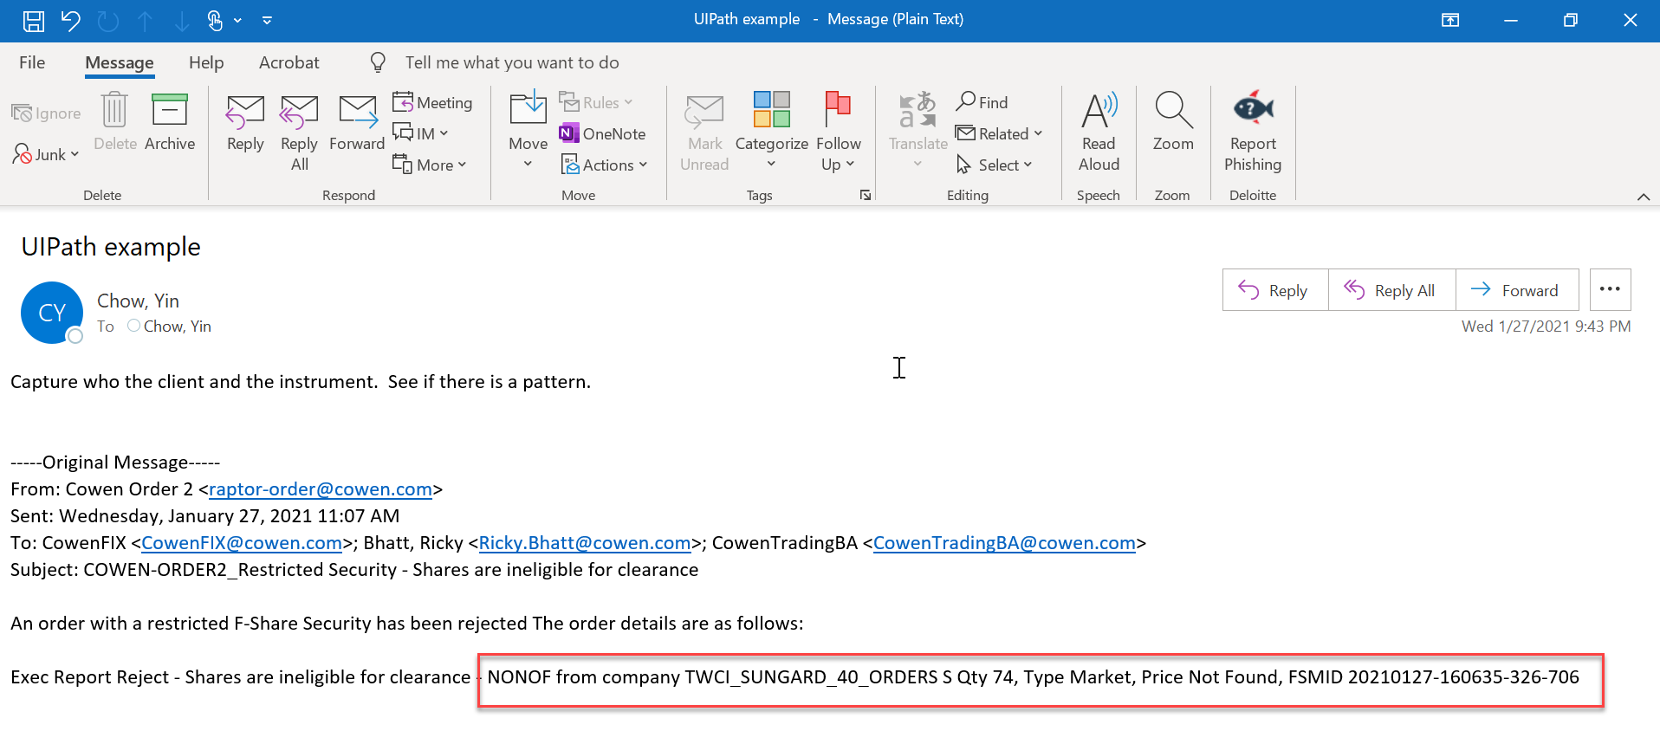

**Sender Name: Raptor Order Server (Example: 5)**

**Common Fields**

* **Sender Name:** Copy the text before less than sign (<) from “From” line in email and paste it in the “Sender Name” column of Email Summary Dashboard Excel (**Raptor Order Server**)
* **Sender Email:** Copy the text between sign (<>) from “From” line in email and paste it in the “Sender Email” column of Email Summary Dashboard Excel (**raptor-order@cowen.com**)

**Email Date:** Copy the text from “Sent” line in email and paste it in the “Email Date” column of Email Summary Dashboard Excel.

* **Email Time:** Capture the time from “Sent” line in email and paste it in “Email Time” column Email Summary Dashboard Excel
* **Subject:** Copy the text after semi colon (:) from “Subject” line and paste it in “Subject” column of Email Summary Dashboard Excel.

**- Refer Screenshot of email below (Example 5):**

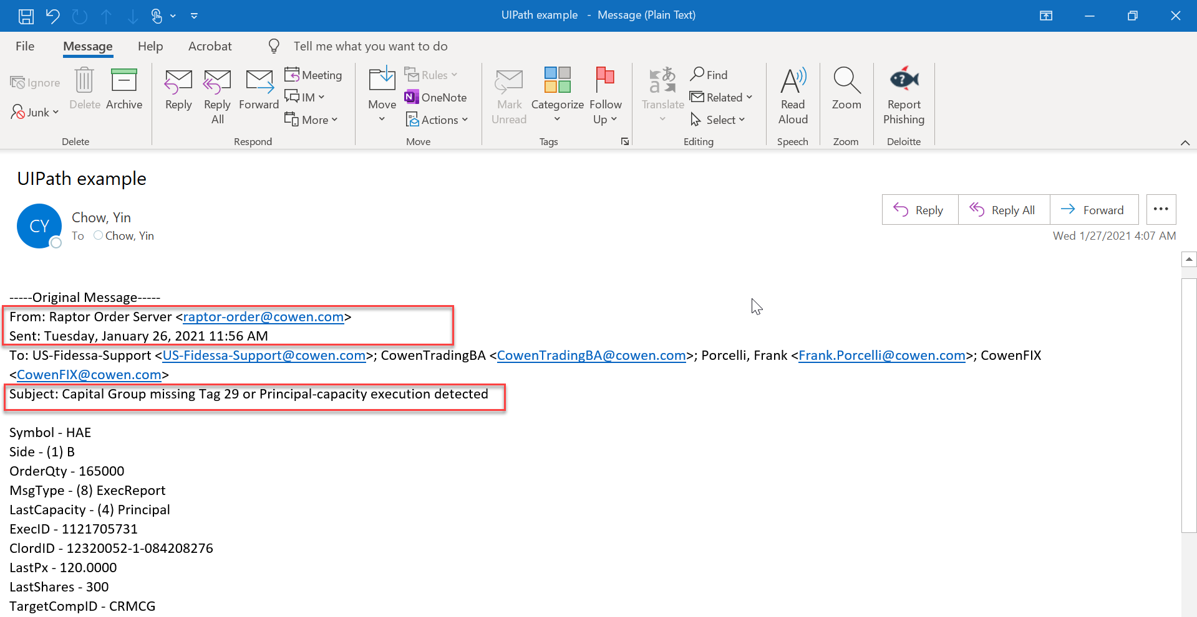

**Variable Fields**

* Copy the text after dash from the line start after “Subject” till Details line and update it in the respective columns in Email Summary Dashboard Excel.

Note: Following are the fields in the email which is to be scraped by bot:Symbol, Side, OrderQty, MsgType, LastCapacity, ExecID, ClordID, LastPx, LastShares, TargetCompID, SenderCompID, TransactTime, ExceBroker, DeliverToCompID and Details

- **Refer Screenshot of email below (Example 5):**

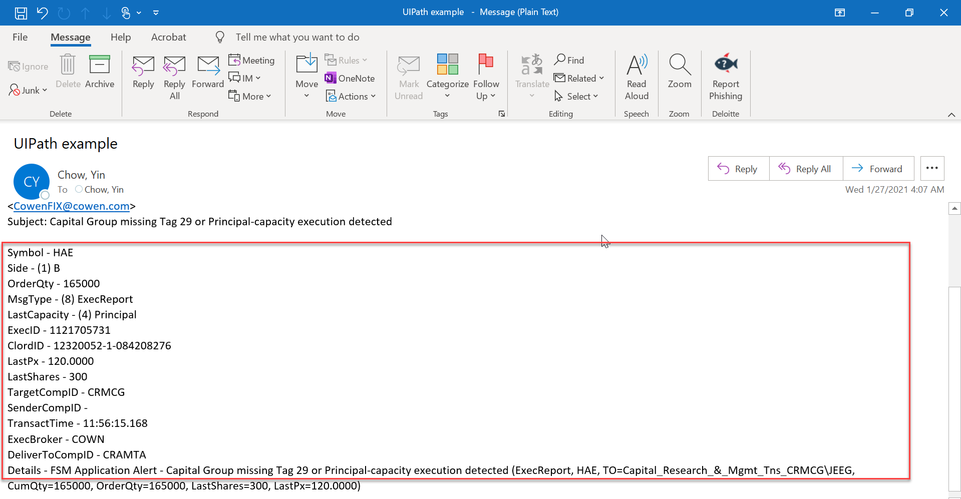

**Sender Name: Raptor IOI Server (Example: 6)**

**Scenario 1: If the email subject is “COWEN-IOI FIX Connection Disabled - "LAB44" then following should be scraped from the email and updated in the Email Summary Dashboards Excel**

**Common Fields**

* **Sender Name:** Copy the text before less than sign (<) from “From” line in email and paste it in the “Sender Name” column of Email Summary Dashboard Excel (Raptor IOI Server).
* **Sender Email:** Copy the text between sign (<>) from “From” line in email and paste it in the “Sender Email” column of Email Summary Dashboard Excel (raptor-ioi@cowen.com)
* **Email Date:** Copy the text from “Sent” line in email and paste it in the “Email Date” column of Email Summary Dashboard Excel.
* **Email Time:** Capture the time from “Sent” line in email and paste it in “Email Time” column Email Summary Dashboard Excel.
* **Subject:** Copy the text after semi colon (:) from “Subject” line and paste it in “Subject” column of Email Summary Dashboard Excel.

**Variable Fields**

* Copy text after “Cowen IOI” from the” Subject” of the email and paste it in the ”COWEN-IOI” column of Excel Summary Dashboard Excel.

**- Refer Screenshot of email below (Example 6)**

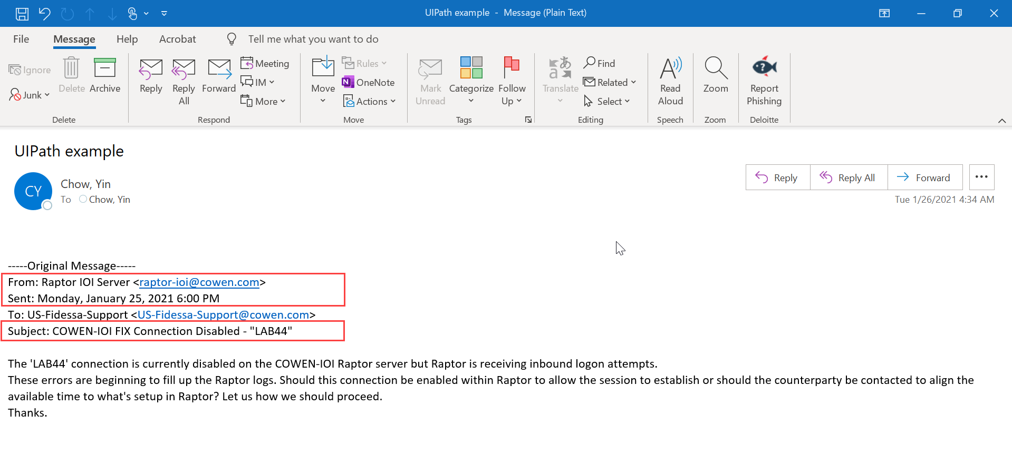

**Scenario 2: If the email subject is “COWEN-IOI Down FIX Connection - "Suspect remote site may have inbound MsgSeqNum lower than expected" then following should be scraped from the email and updated in the Email Summary Dashboards Excel**

**Common Fields**

* **Sender Name:** Copy the text before less than sign (<) from “From” line in email and paste it in the “Sender Name” column of Email Summary Dashboard Excel (Raptor IOI Server)
* **Sender Email:** Copy the text between sign (<>) from “From” line in email and paste it in the “Sender Email” column of Email Summary Dashboard Excel ([raptor-ioi@cowen.com](mailto:raptor-ioi@cowen.com)).
* **Email Date:** Copy the text from “Sent” line in email and paste it in the “Email Date” column of Email Summary Dashboard Excel.
* **Email Time:** Capture the time from “Sent” line in email and paste it in “Email Time” column Email Summary Dashboard Excel.
* **Subject:** Copy the text after semi colon (:) from “Subject” line and paste it in “Subject” column of Email Summary Dashboard Excel.

**Variable Fields**

* Copy text after “Cowen IOI” from the” Subject” of the email and paste it in the ”COWEN-IOI” column of Excel Summary Dashboard Excel.
* Copy the text in inverted commas after “connection” from 1st line of 1st paragraph of email body and paste it in the “Connection” column of Email Summary Dashboard Excel.

**- Refer Screenshot of email below (Example 6)**

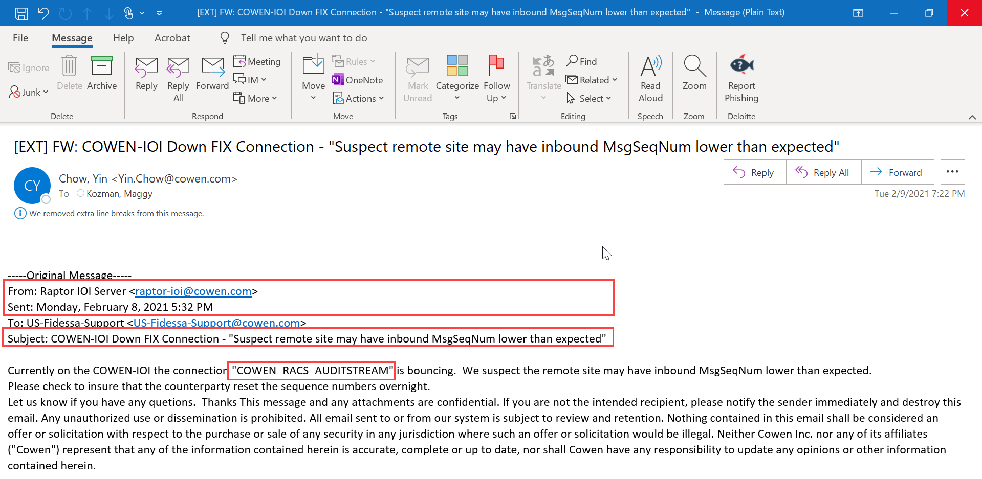

**Sender Name: COWEN-ORDER-EURO (Example 9)**

**Common Fields**

* **Sender Name:** Copy the text before less than sign (<) from email and paste it in the “Sender Name” column of Email Summary Dashboard Excel (COWEN-ORDER-EURO).
* **Sender Email:** Copy the text between sign (<>) from in email and paste it in the “Sender Email” column of Email Summary Dashboard Excel(raptor-IOI@cowen.com).
* **Email Date:** Copy the date from top right-hand side corner of email and paste it in the “Email Date” column of Email Summary Dashboard Excel.
* **Email Time:** Copy the date from top right-hand side corner of email and paste it in the “Email Date” column of Email Summary Dashboard Excel.
* **Subject:** Copy the text from top of the email and paste it in “Subject” column of Email Summary Dashboard Excel.

**- Refer Screenshot of email below for common fields (Example 9)**

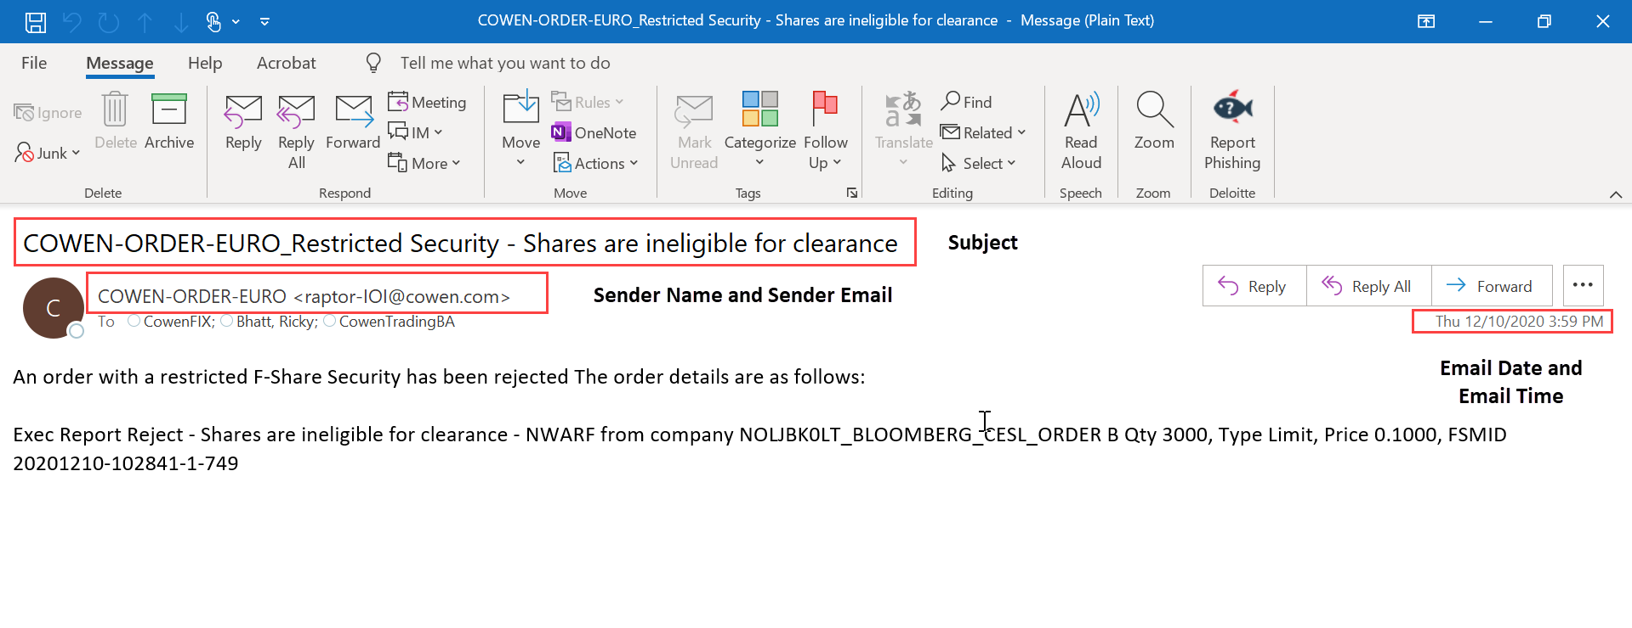

**Variable Fields**

* **QTY:** Copy number (“3000”) after word “QTY” from the last line of email body and pasCOWEN-ORDER-EURO te in the “QTY” column of Email Summary Dashboard Excel.
* **FSMID**: Copy number (“20201210-102841-1-749”) after the word “FSMIS” from the last line of email body and paste it in the “FSMID” column of Email Summary Dashboard Excel.
* **Company:** Copy text (“NOLJBK0LT_BLOOMBERG_CESL”) after word “company” from the last line of email body and paste in the “Company” column of Email Summary Dashboard Excel.
* **Order**: Copy text (“B”) after word “Order” from the last line of email body and paste in the “Order” column of Email Summary Dashboard Excel.

**- Refer screenshot of email below for variable fields (Example 9)**

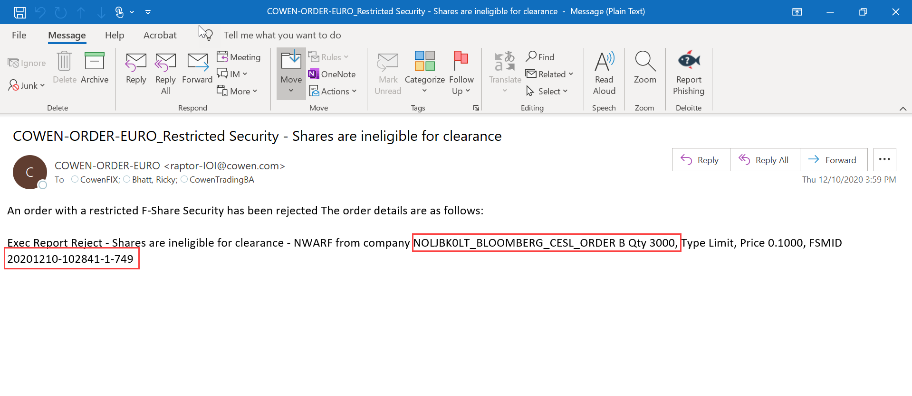

**Sender Name: COWEN-ORDER-EURO-QA (Example 10)**

**Common Fields**

* **Sender Name:** Copy the text before less than sign (<) from email and paste it in the “Sender Name” column of Email Summary Dashboard Excel (COWEN-ORDER-EURO-QA).
* **Sender Email:** Copy the text between sign (<>) from in email and paste it in the “Sender Email” column of Email Summary Dashboard Excel ([raptor-order@cowen.com](mailto:raptor-order@cowen.com))
* **Email Date:** Copy the date from top right-hand side corner of email and paste it in the “Email Date” column of Email Summary Dashboard Excel.
* **Email Time:** Copy the date from top right-hand side corner of email and paste it in the “Email Date” column of Email Summary Dashboard Excel.
* **Subject:** Copy the text from top of the email and paste it in “Subject” column of Email Summary Dashboard Excel.

**- Refer Screenshot of email below for common fields (Example 10)**

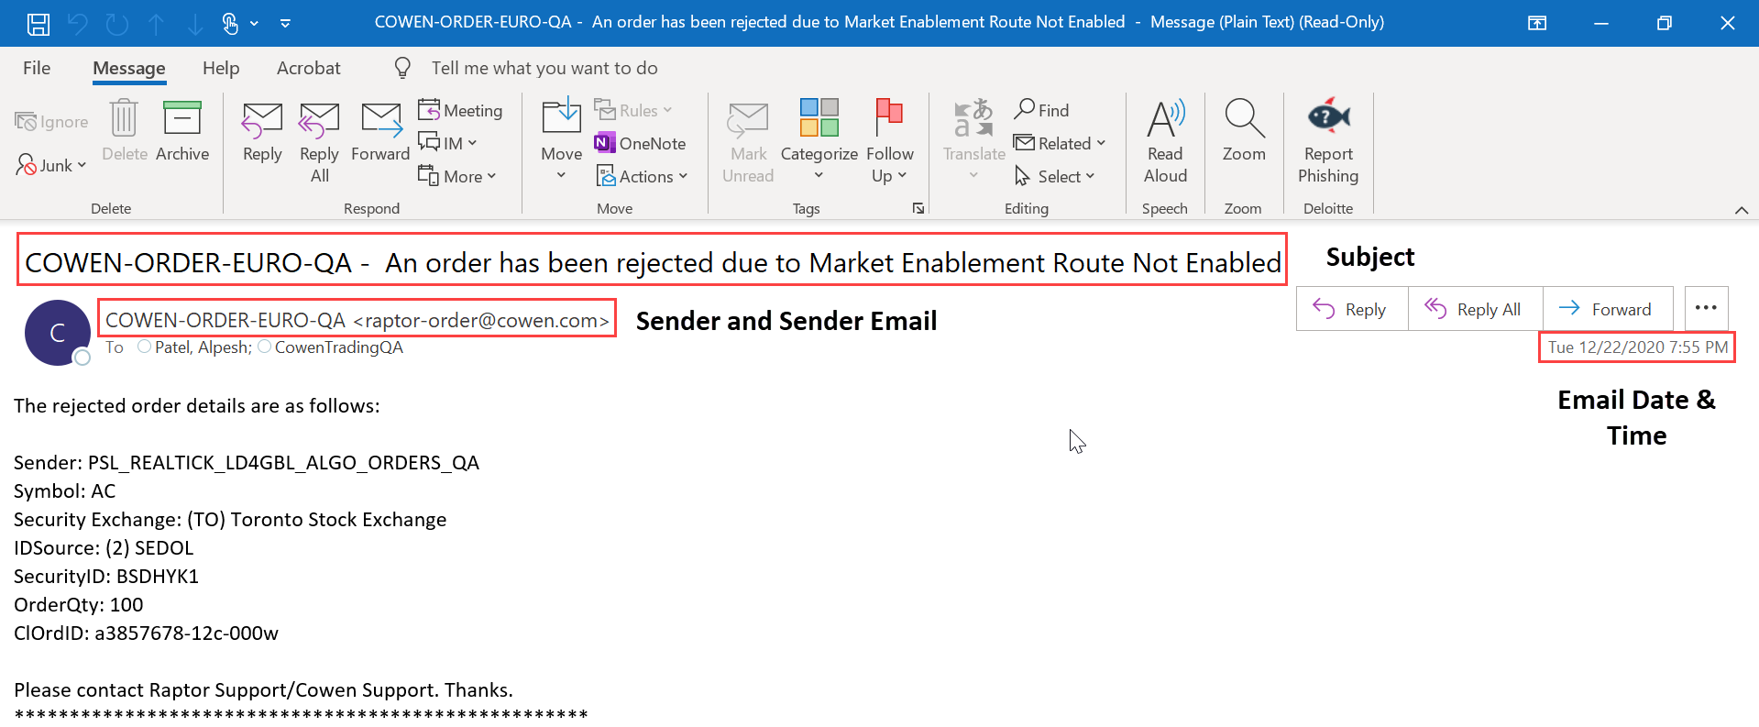

**Variable Fields**

* **Error:** Copy text (“An order has been rejected due to Market Enablement Route Not Enabled”) after dash (-) from top of email and paste it in the Email Summary Dashboard Excel.
* Copy the text after semi colon (:) from each line starting from “Sender” and “CIOrdID” and paste it in the respective columns in Email Summary Dashboard Excel.

Note: Following are the fields in the email which is to be scraped by bot: Sender; Symbol; Security Exchange; IDSource; SecurityID; OrderQty and CIOrdID.

**- Refer the screenshot below for variable fields (Example 10)**

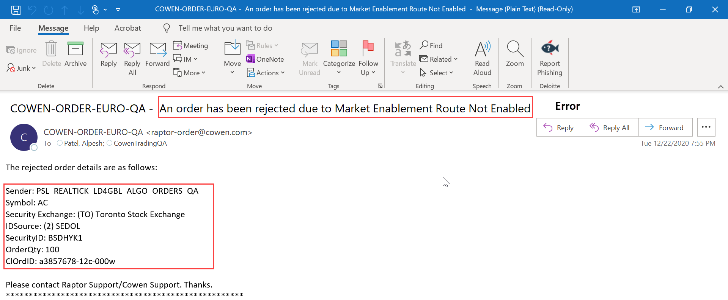

### Category 2: Log to DB: Check against the list of morning jobs and mark it sucessful

**Sender Name: COWEN ORDER 2 (Example 25)**

**Common Fields**

* **Sender Name:** Copy the text before less than sign (<) from “From” line in email and paste it in the “Sender Name” column of Email Summary Dashboard Excel (Cowen Order 2)
* **Sender Email:** Copy the text between sign (<>) from “From” line in email and paste it in the “Sender Email” column of Email Summary Dashboard Excel (raptor-order@cowen.com)
* **Email Date:** Copy the text from “Sent” line in email and paste it in the “Email Date” column of Email Summary Dashboard Excel.
* **Email Time:** Capture the time from “Sent” line in email and paste it in “Email Time” column Email Summary Dashboard Excel.
* **Subject:** Copy the text after semi colon (:) from “Subject” line and paste it in “Subject” column of Email Summary Dashboard Excel.

**- Refer Screenshot of email below (Example 25):**

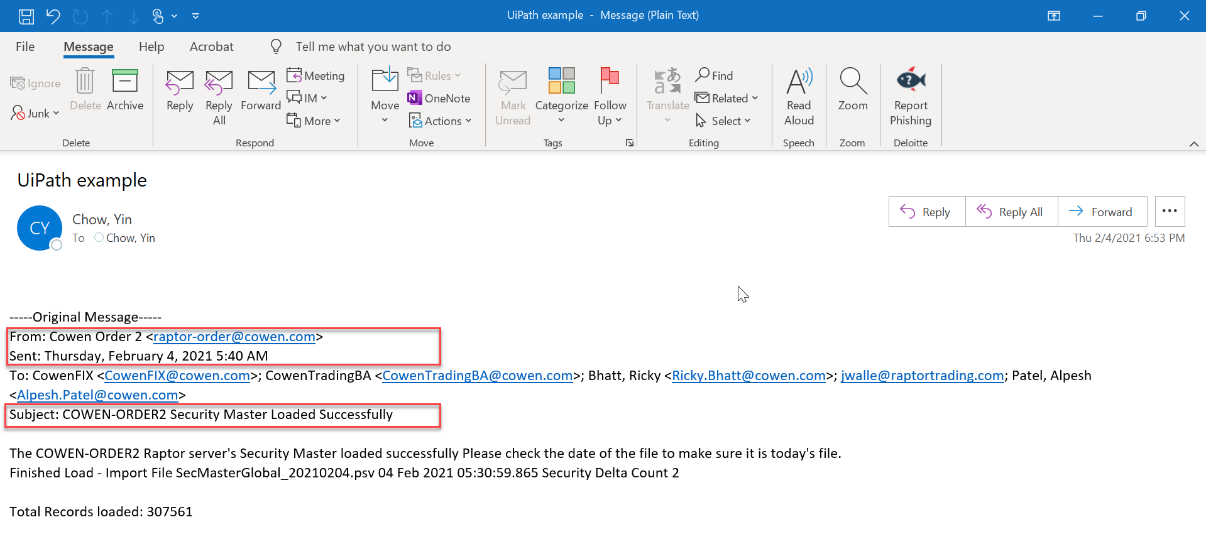

**Variable Fields**

* **Finished Load:**  Copy the text after word “file” till psv (**SecMasterGlobal_20210204.psv**) from second last line of email body and put it in the “Finished Load” column of Email Summary Dashboard Excel.
* **Total Record Loaded:** Copy the number (**307561**) after semi colon (:) from last line of email body and paste it in the “Total Records loaded” column of Email Summary Dashboard Excel.

**- Refer Screenshot of email below (Example 25):**

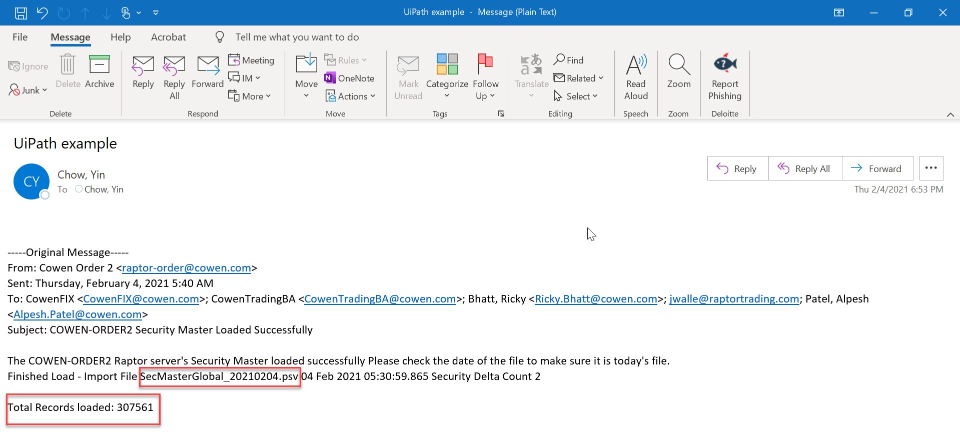

**Sender Name: COWEN-ORDER-EURO (Example 7 and 8)**

**Scenario 1: If success, bot will copy the following fields from email and update the Email Summary Dashboard Excel (Example 7)**

**Common Fields**

* **Sender Name:** Copy the text before less than sign (<) from “From” line in email and paste it in the “Sender Name” column of Email Summary Dashboard Excel (COWEN-ORDER-EURO).
* **Sender Email:** Copy the text between sign (<>) from “From” line in email and paste it in the “Sender Email” column of Email Summary Dashboard Excel (raptor-IOI@cowen.com)
* **Email Date:** Copy the text from “Sent” line in email and paste it in the “Email Date” column of Email Summary Dashboard Excel.
* **Email Time:** Capture the time from “Sent” line in email and paste it in “Email Time” column Email Summary Dashboard Excel.
* **Subject:** Copy the text after semi colon (:) from “Subject” line and paste it in “Subject” column of Email Summary Dashboard Excel.

**Variable Fields**

* **Data Records Loaded Successfully:** Copy the number ("304898”) after semi colon (:) from last line (“Total Records loaded”) of email and paste it in the Email Summary Dashboard Excel.
* **Data File:** Copy the text (SecMasterGlobal_20210124.psv) till .psv after word “file” from second last line of email body paste it in the Email Summary Dashboard Excel.

**- Refer Screenshot of email below (Example 7)**

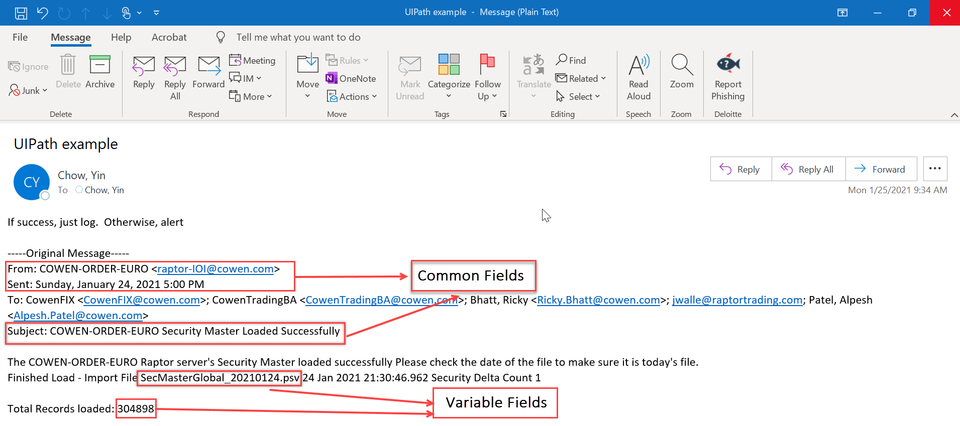

**Scenario 2: If failure, bot will send an alert email with “Subject” (i.e. COWEN ORDER-EURO) to** [**TradeProcessMon@cowen.com**](mailto:TradeProcessMon@cowen.com) **for investigation. Further bot will copy the following fields from email and update the Email Summary Dashboard Excel. (Example 8)**

**Common Fields**

* **Sender Name:** Copy the text before less than sign (<) from “From” line in email and paste it in the “Sender Name” column of Email Summary Dashboard Excel (COWEN-ORDER-EURO).
* **Sender Email:** Copy the text between sign (<>) from “From” line in email and paste it in the “Sender Email” column of Email Summary Dashboard Excel ([raptor-IOI@cowen.com](mailto:raptor-IOI@cowen.com)).
* **Email Date:** Copy the text from “Sent” line in email and paste it in the “Email Date” column of Email Summary Dashboard Excel.
* **Email Time:** Capture the time from “Sent” line in email and paste it in “Email Time” column Email Summary Dashboard Excel.
* **Subject:** Copy the text after semi colon (:) from “Subject” line and paste it in “Subject” column of Email Summary Dashboard Excel

**- Refer Screenshot of email below (Example 8)**

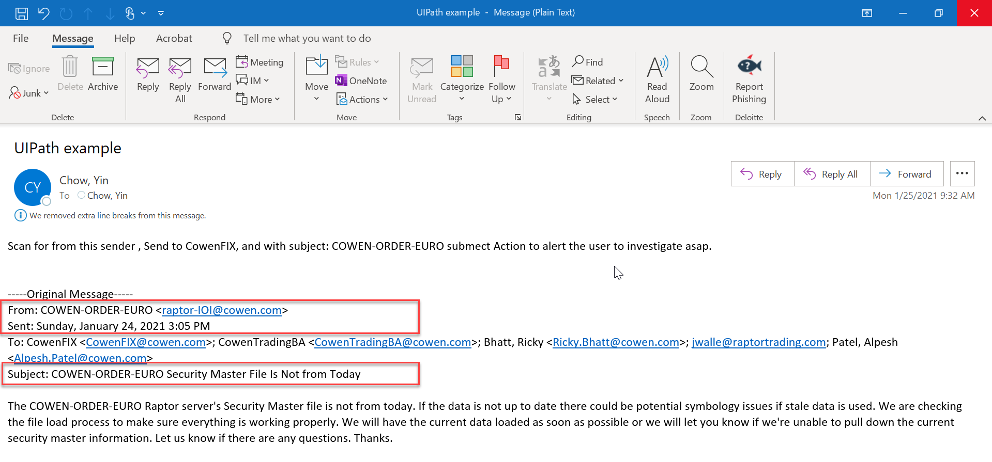

**Sender Name: Fidessa FDM (Example 14)**

**Common Fields**

* **Sender Name:** Copy the text before less than sign (<) from “From” line in email and paste it in the “Sender Name” column of Email Summary Dashboard Excel (Fidessa fdm).
* **Sender Email:** Copy the text between sign (<>) from “From” line in email and paste it in the “Sender Email” column of Email Summary Dashboard Excel (fdm@fidessa.com)
* **Email Date:** Copy the text from “Sent” line in email and paste it in the “Email Date” column of Email Summary Dashboard Excel.
* **Email Time:** Capture the time from “Sent” line in email and paste it in “Email Time” column Email Summary Dashboard Excel.
* **Subject:** Copy the text after semi colon (:) from “Subject” line and paste it in “Subject” column of Email Summary Dashboard Excel

**- Refer Screenshot below for common Fields (Example 14)**

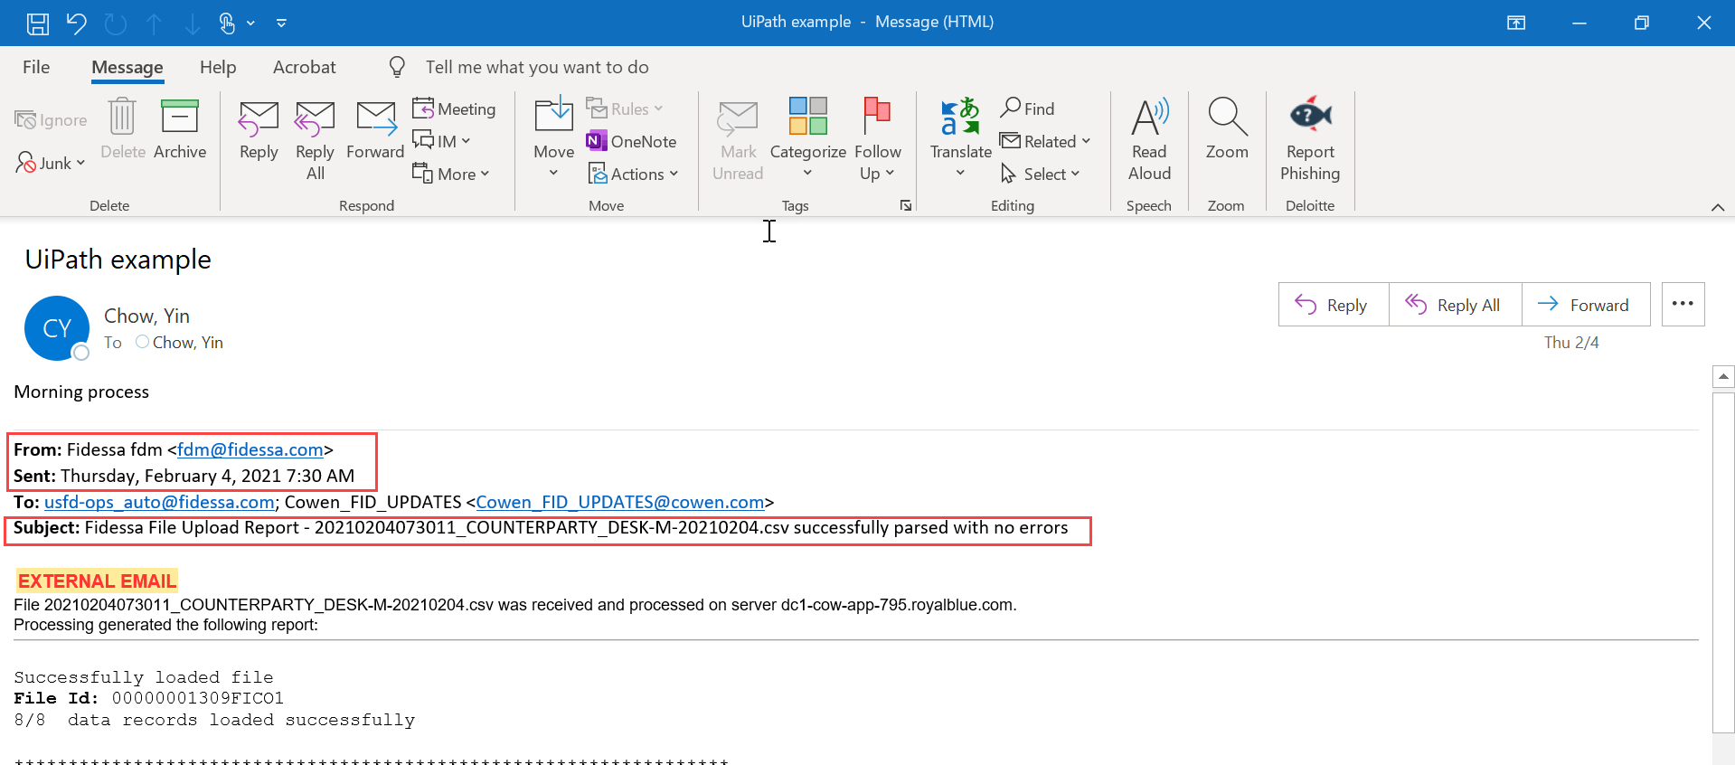

**Variable Fields**

* Bot will follow the step followed in Example 12 above for updating the same variable fields in to Email Summary Dashboard Excel**.**

**- Refer Screenshot of email below (Example 14)**

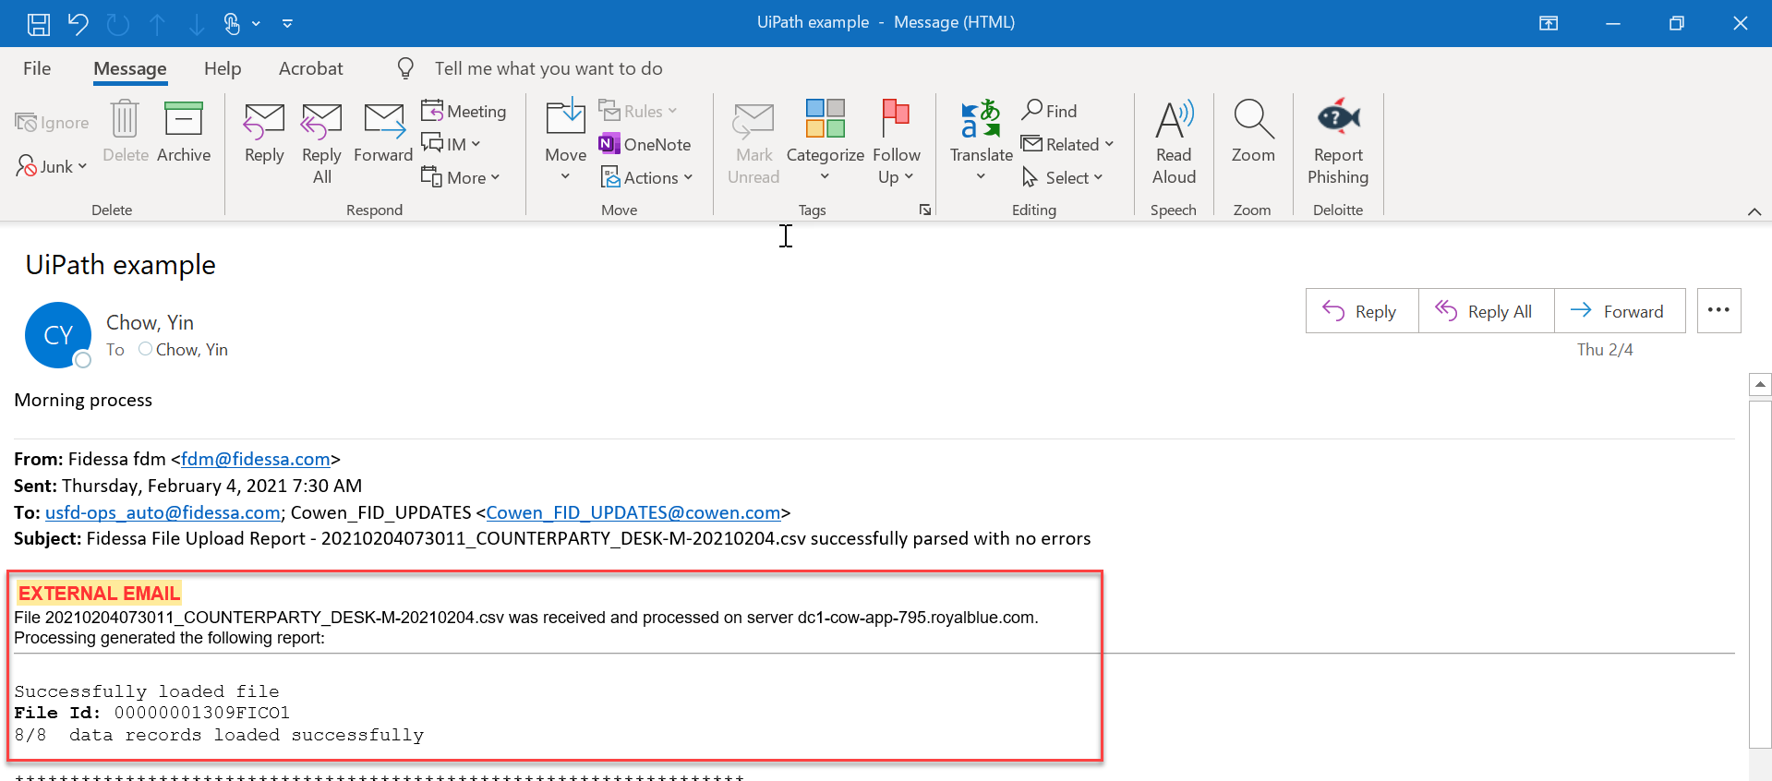

**Sender Name: Fidessa@fidessa.com (Example 24)**

**Common Fields**

* **Sender Name:** Copy the text before less than sign (<) from “From” line in email and paste it in the “Sender Name” column of Email Summary Dashboard Excel (Fidessa@fidessa.com).
* **Sender Email:** Copy the text between sign (<>) from “From” line in email and paste it in the “Sender Email” column of Email Summary Dashboard Excel (Fidessa@fidessa.com)
* **Email Date:** Copy the text from “Sent” line in email and paste it in the “Email Date” column of Email Summary Dashboard Excel.
* **Email Time:** Capture the time from “Sent” line in email and paste it in “Email Time” column Email Summary Dashboard Excel.
* **Subject:** Copy the text after semi colon (:) from “Subject” line and paste it in “Subject” column of Email Summary Dashboard Excel

**- Refer screenshot of email below for the common fields (Example 24)**

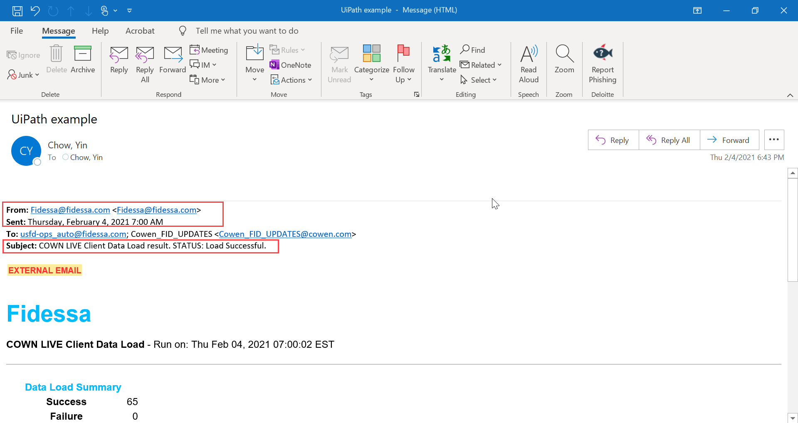

**Variable Fields**

* **Data Records Loaded Successfully:** Copy the number after “Success” under the “Data Load Summary” header in email and paste it in the “ Data Records Loaded Successfully” column of Email Summary Dashboard Excel.
* **Data Records Not Loaded:** Copy the number after “Failure” under the “Data Load Summary” header in email and paste it in the “ Data Records Not Loaded” column of Email Summary Dashboard Excel.
* **Total Records loaded:** Copy the number after “Total Record Processed” under the “Data Load Summary” header in email and paste it in the “ Data Records Not Loaded” column of Email Summary Dashboard Excel.

**- Refer screenshot below for getting the following fields (Data Records Loaded Successfully; Data Records Not Loaded; Total Records loaded)**

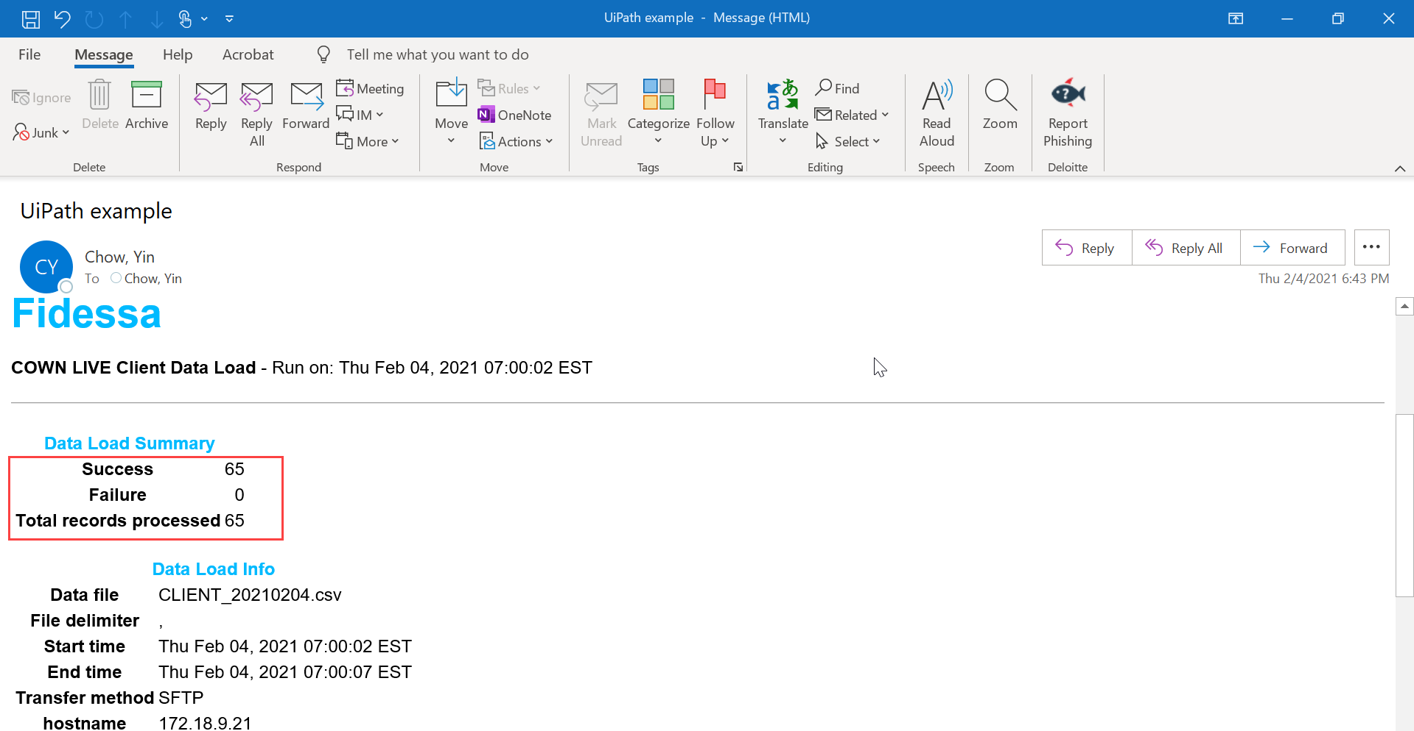

* **Data file:** Copy the text after “Data file” under the “Data Load Info” header in email and paste it in the “ Data File” column of Email Summary Dashboard Excel.

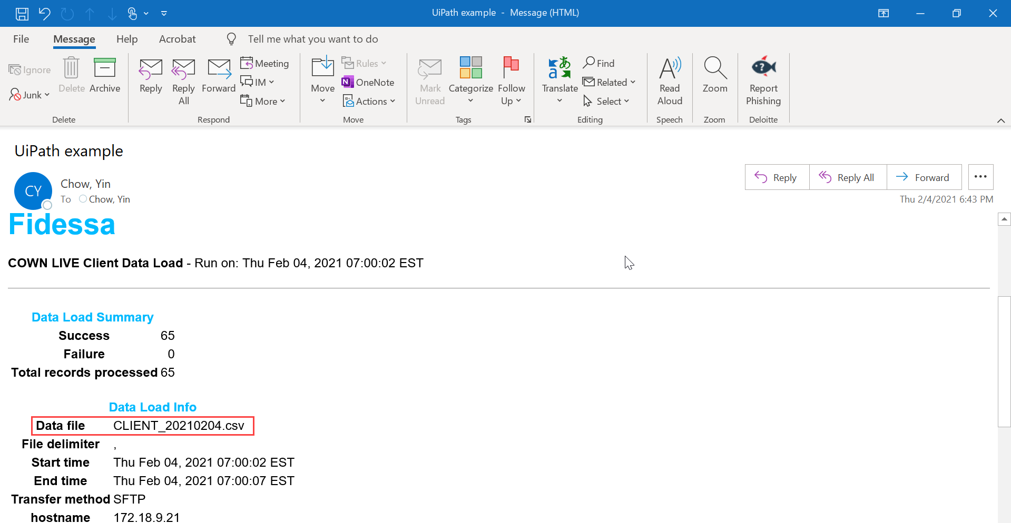

### Category 3: Log to DB (Example 2 & 4)

**Sender Name: Raptor Footprints (Example 2)**

**Common Fields**

* **Sender Name:** Copy the text before less than sign (<) from “From” line in email and paste it in the “Sender Name” column of Email Summary Dashboard Excel (Raptor Footprints)
* **Sender Email:** Copy the text between sign (<>) from “From” line in email and paste it in the “Sender Email” column of Email Summary Dashboard Excel (Footprints@raptortrading.com)
* **Email Date:** Copy the text from “Sent” line in email and paste it in the “Email Date” column of Email Summary Dashboard Excel.
* **Email Time:** Capture the time from “Sent” line in email and paste it in “Email Time” column Email Summary Dashboard Excel.
* **Subject:** Copy the text after semi colon (:) from “Subject” line and paste it in “Subject” column of Email Summary Dashboard Excel.

**Variable Fields**

* Copy the data from the headers (**Incident Number, Status, Raptor Server Name, Title, Date Submitted and Scheduled Work Date**) and paste it the respective column of Email Summary Dashboard Excel.

- **Refer screenshot of email below (Example 2)**:

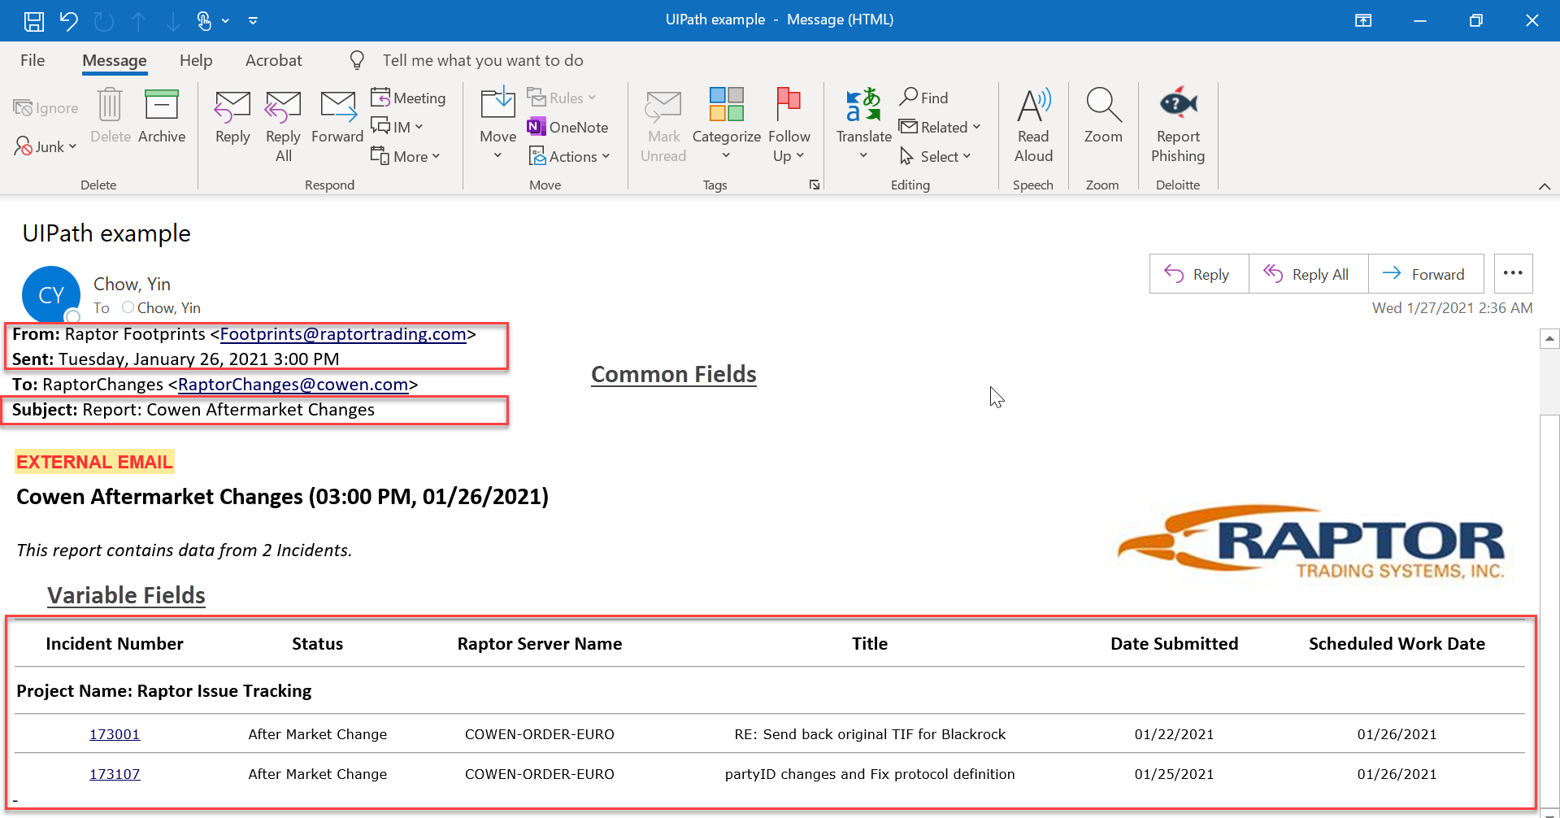

**Sender Name: Raptor Footprints (Example 4)**

**Common Fields**

* **Sender Name:** Copy the text before less than sign (<) from “From” line in email and paste it in the “Sender Name” column of Email Summary Dashboard Excel (Raptor Footprints)
* **Sender Email:** Copy the text between sign (<>) from “From” line in email and paste it in the “Sender Email” column of Email Summary Dashboard Excel ([Footprints@raptortrading.com](mailto:Footprints@raptortrading.com))
* **Email Date:** Copy the text from “Sent” line in email and paste it in the “Email Date” column of Email Summary Dashboard Excel
* **Email Time:** Capture the time from “Sent” line in email and paste it in “Email Time” column Email Summary Dashboard Excel.
* **Subject:** Copy the text after semi colon (:) from “Subject” line and paste it in “Subject” column of Email Summary Dashboard Excel.

**Variable Fields**

* Copy text (i.e. ”There were no matches to your query”) in the body of email and put in the “Email Text” column of Email Summary Dashbaord Excel.

**Refer Screenshot of email below (Example 4)**

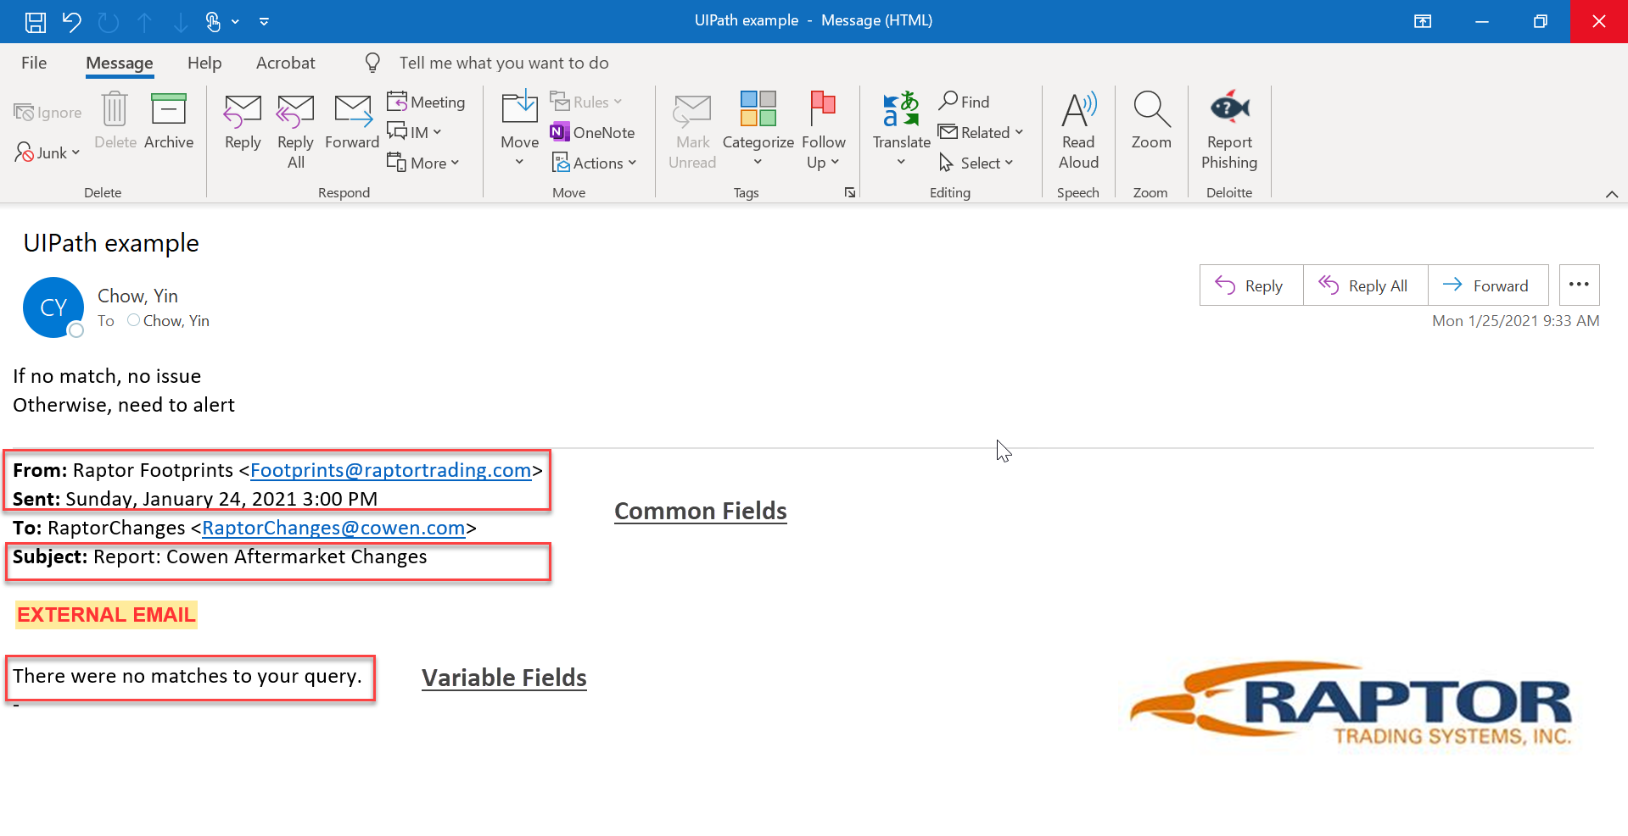

### Category 4: Log to DB: User will check the dasboard to ensure all trades processed

**Sender Name:** NotReply@cowen.com **(Example 11)**

**Common Fields Log to DB-Morning Jobs**

* **Sender Name:** Copy the sender email id and paste it in the “Sender Name” column of Email Summary Dashboard Excel (NotReply@cowen.com).
* **Sender Email:** Copy the sender email id and paste it in the “Sender Name” column of Email Summary Dashboard Excel (NotReply@cowen.com)
* **Email Date:** Copy the date from top right-hand side corner of email and paste it in the “Email Date” column of Email Summary Dashboard Excel.
* **Email Time:** Copy the date from top right-hand side corner of email and paste it in the “Email Date” column of Email Summary Dashboard Excel.
* **Subject:** Copy the text from top of the email and paste it in “Subject” column of Email Summary Dashboard Excel.

**- Refer screenshot of email below for common fields:**

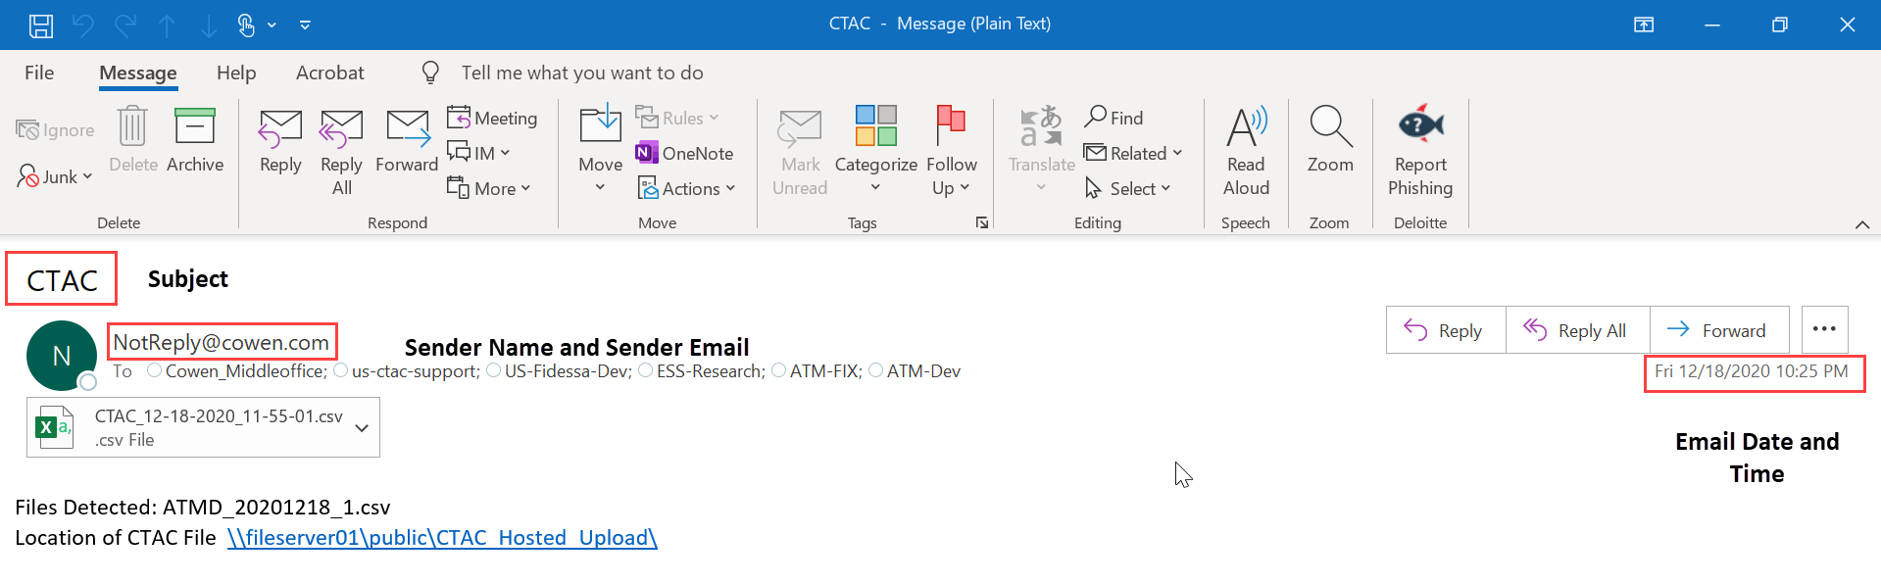

**Variable Fields**

* **Record**: Open the excel file attached in email, check the Column A (“Row Type”) and update the “Record” column of Email Summary Dashboard Excel.

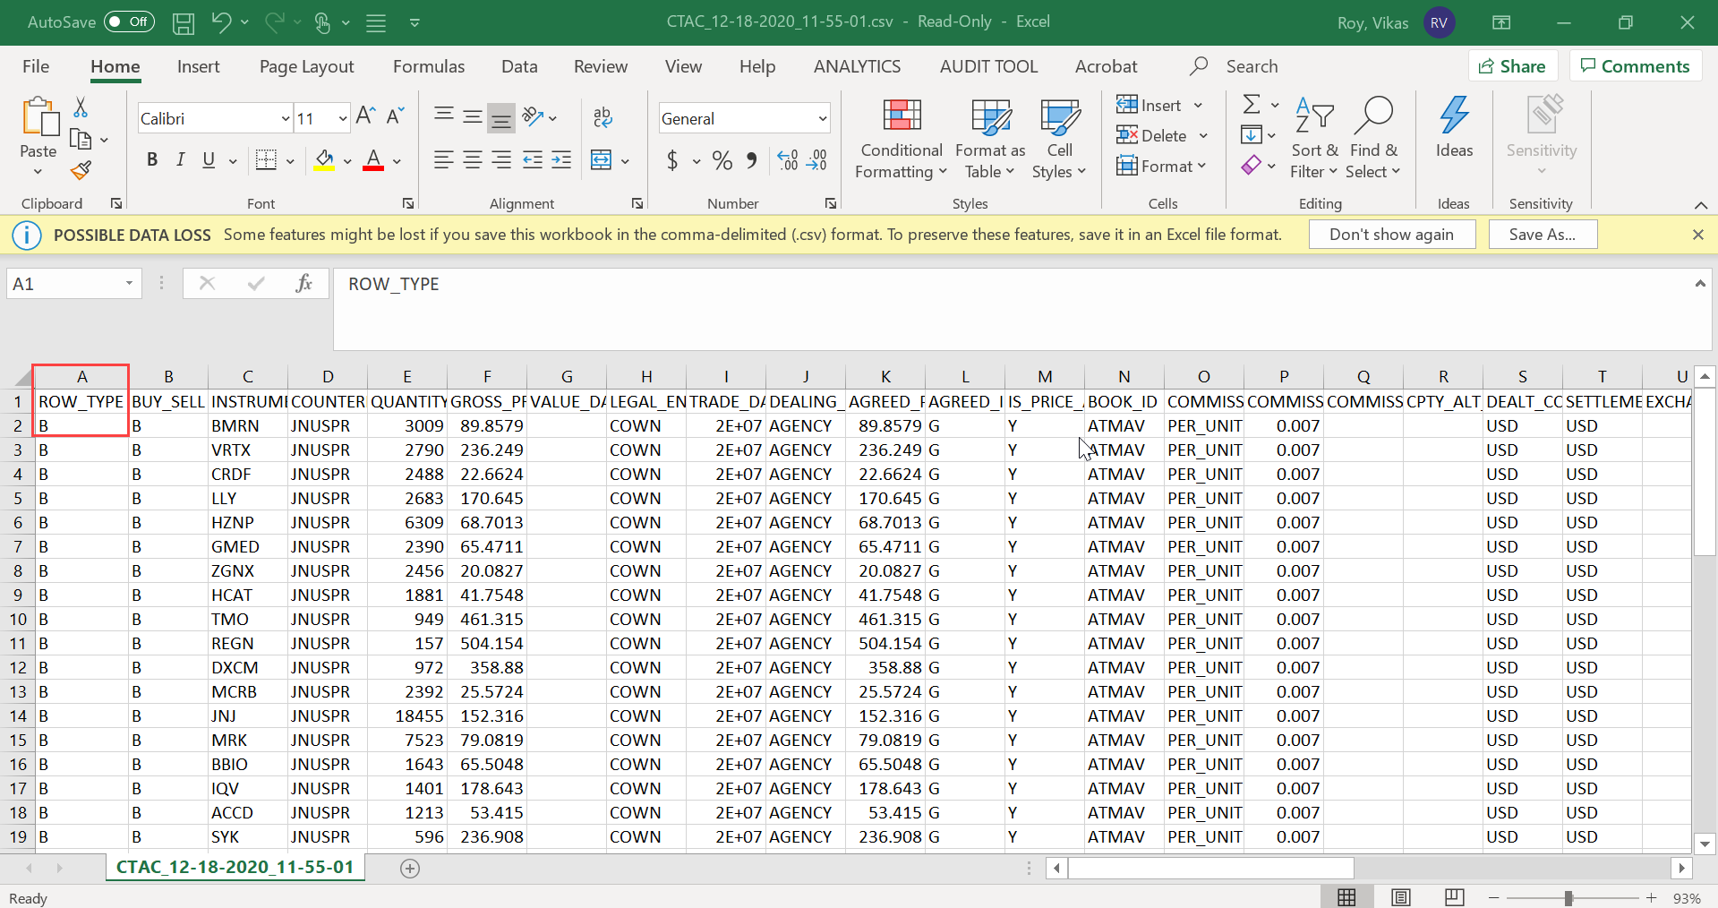

* **Total Data Records:** Select the data below header till last record in Column A (Row Type) in attached excel report to get the count of record and update the “Total Data Records” column of Excel Summary Dashboard Excel.

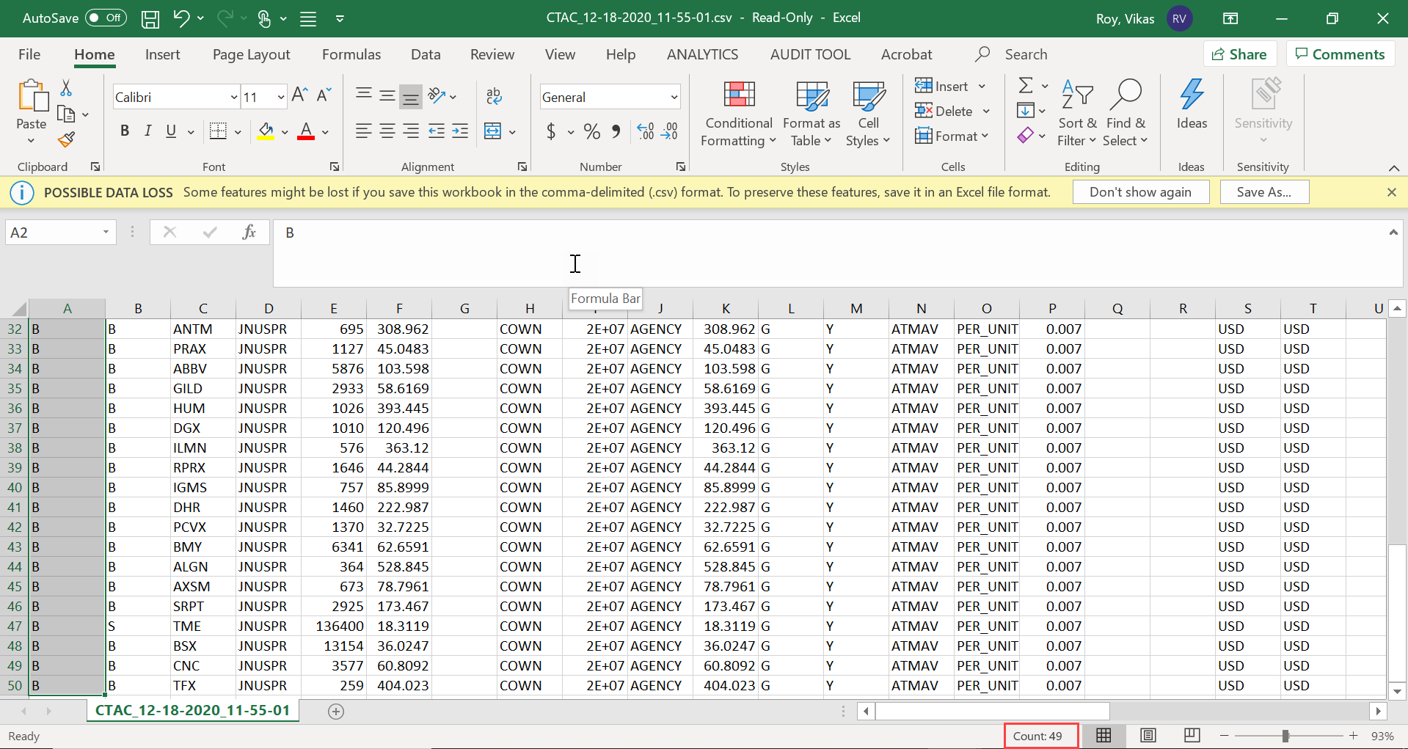

* **File Detected:** Copy the Text after semi colon sign (:) in File detected line of email and paste it in the “File Detected” column of Email Summary Dashboard Excel.

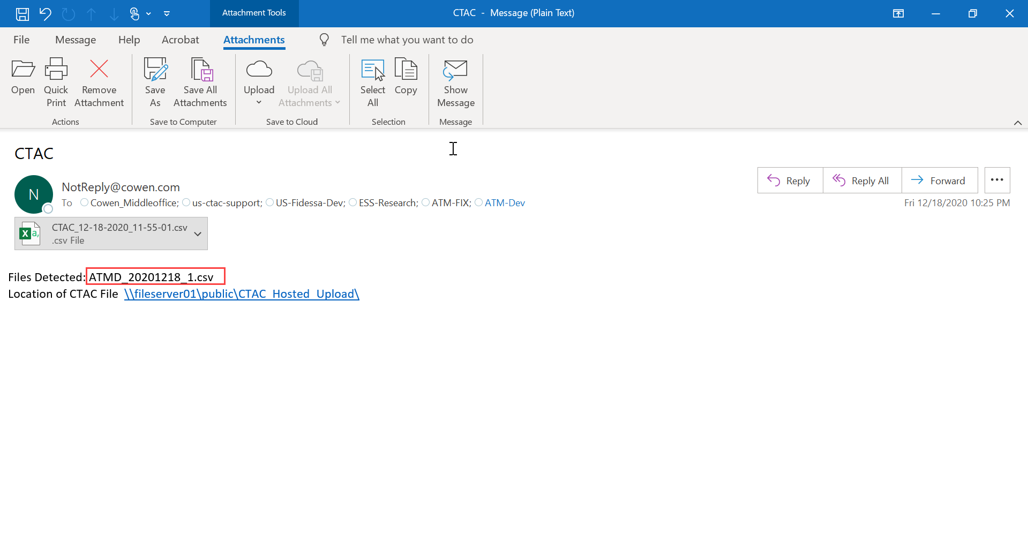

* **File Location:** Copy the link from the last line of email body and paste it in the “File Location” column of Email Summary Dashboard Excel.

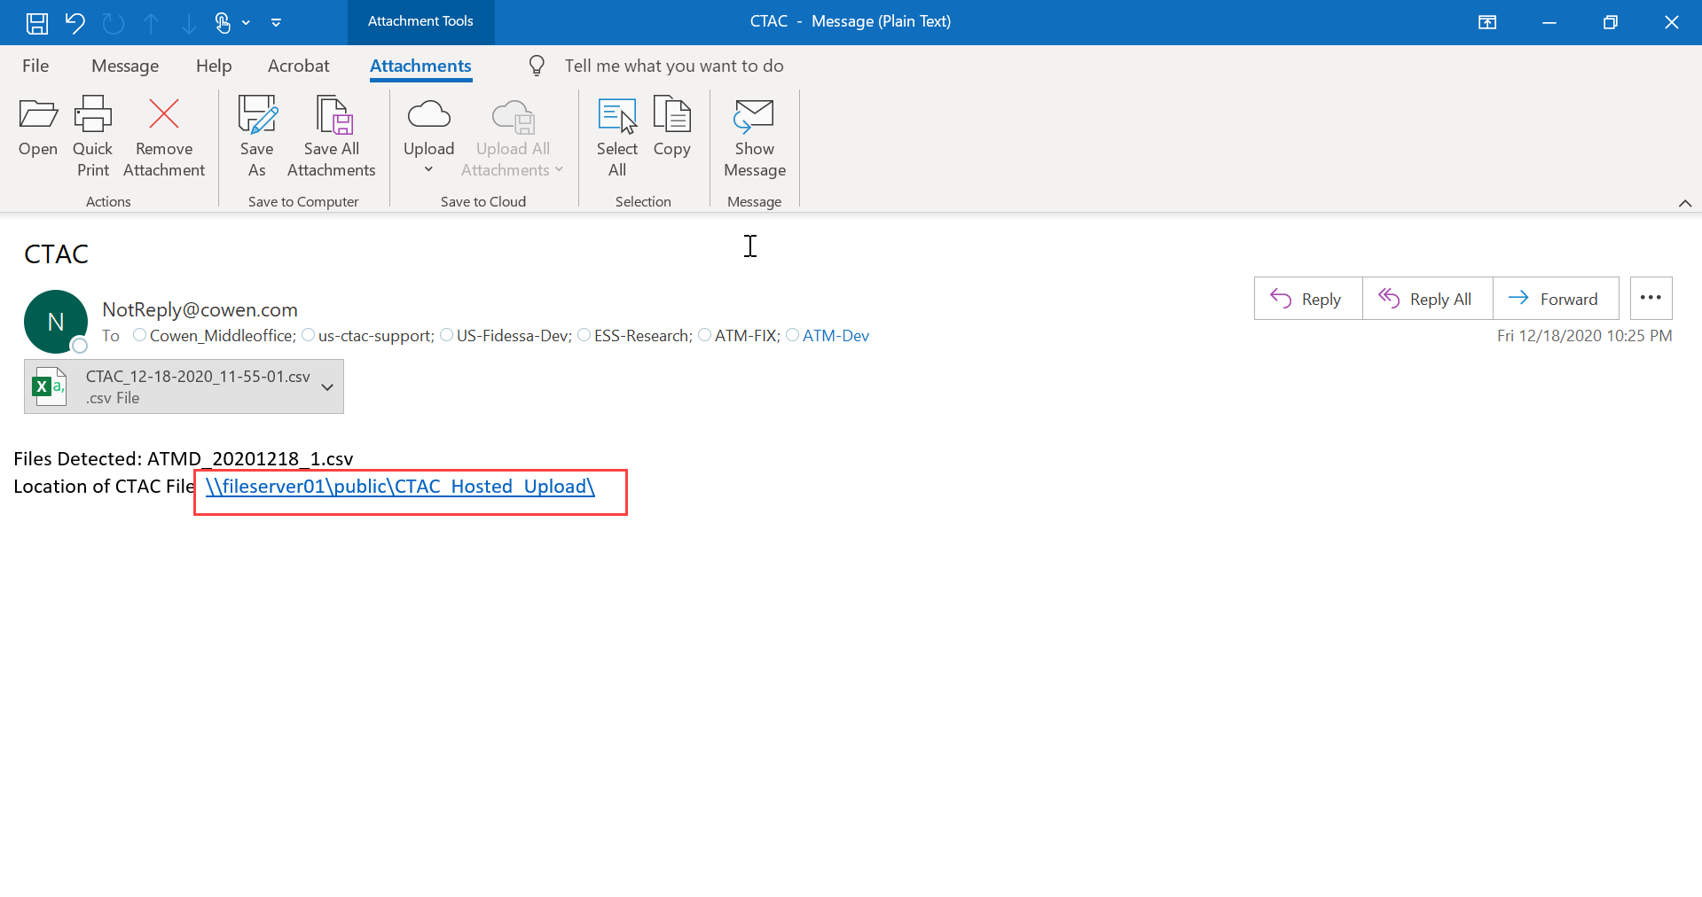

### Category 5: Log to DB: IT team will review dashboard to investigate (Example 12)

**Sender Name: Fidessa FDM account (Example 12)**

**Common Fields**

* **Sender Name:** Copy the text before less than sign (<) from email and paste it in the “Sender Name” column of Email Summary Dashboard Excel (Fidessa FDM Account).
* **Sender Email:** Copy the text between sign (<>) from in email and paste it in the “Sender Email” column of Email Summary Dashboard Excel (global.support@fidessa.com)
* **Email Date:** Copy the date from top right-hand side corner of email and paste it in the “Email Date” column of Email Summary Dashboard Excel.
* **Email Time:** Copy the date from top right-hand side corner of email and paste it in the “Email Date” column of Email Summary Dashboard Excel.
* **Subject:** Copy the text from top of the email and paste it in “Subject” column of Email Summary Dashboard Excel.

**- Refer screenshot below for the common fields (Example 12)**

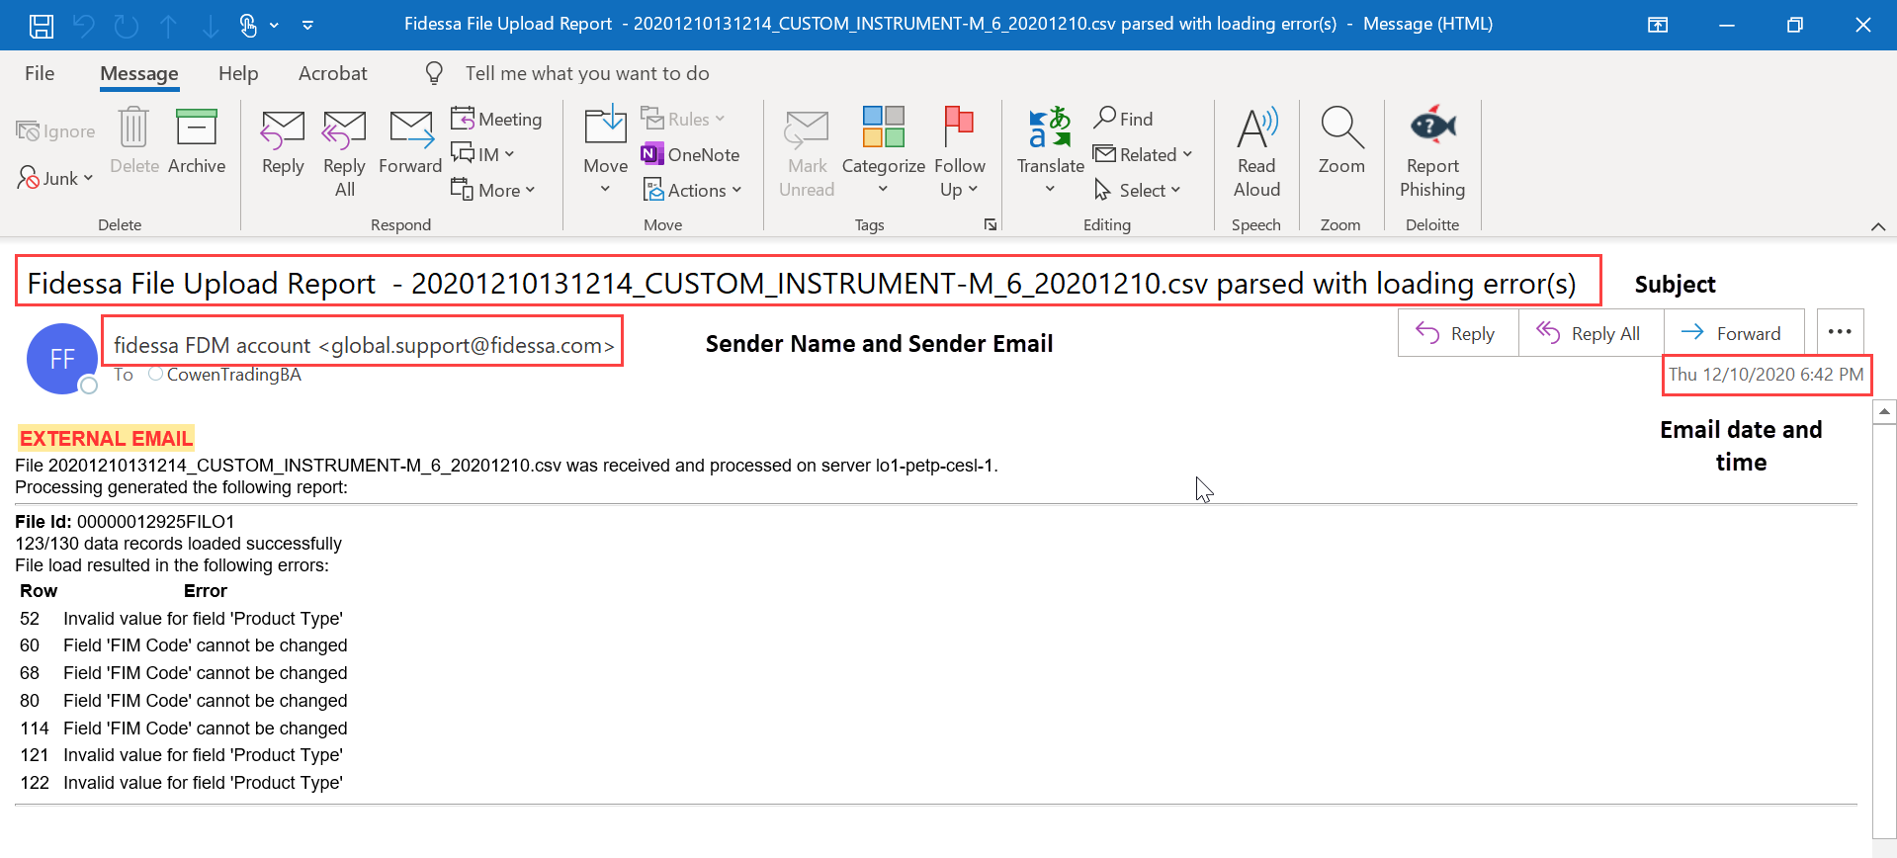

**Variable Fields**

* **Data file**: Copy text till .csv after ”File” from first line below External Mail heading in email and paste it in the “Data File” column in Email Summary Dashboard Excel.

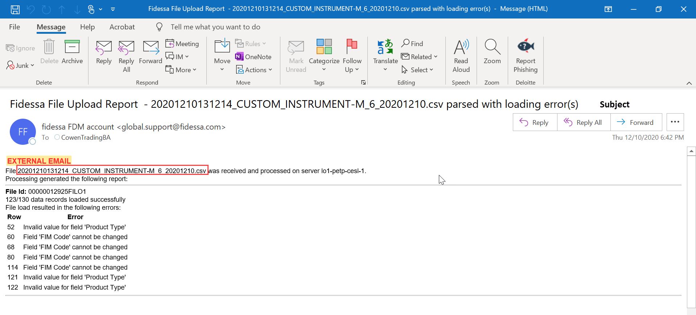

* **Server:** Copy text after ”server” from first line below External Mail heading in email and paste it in the “Sever” column in Email Summary Dashboard Excel.

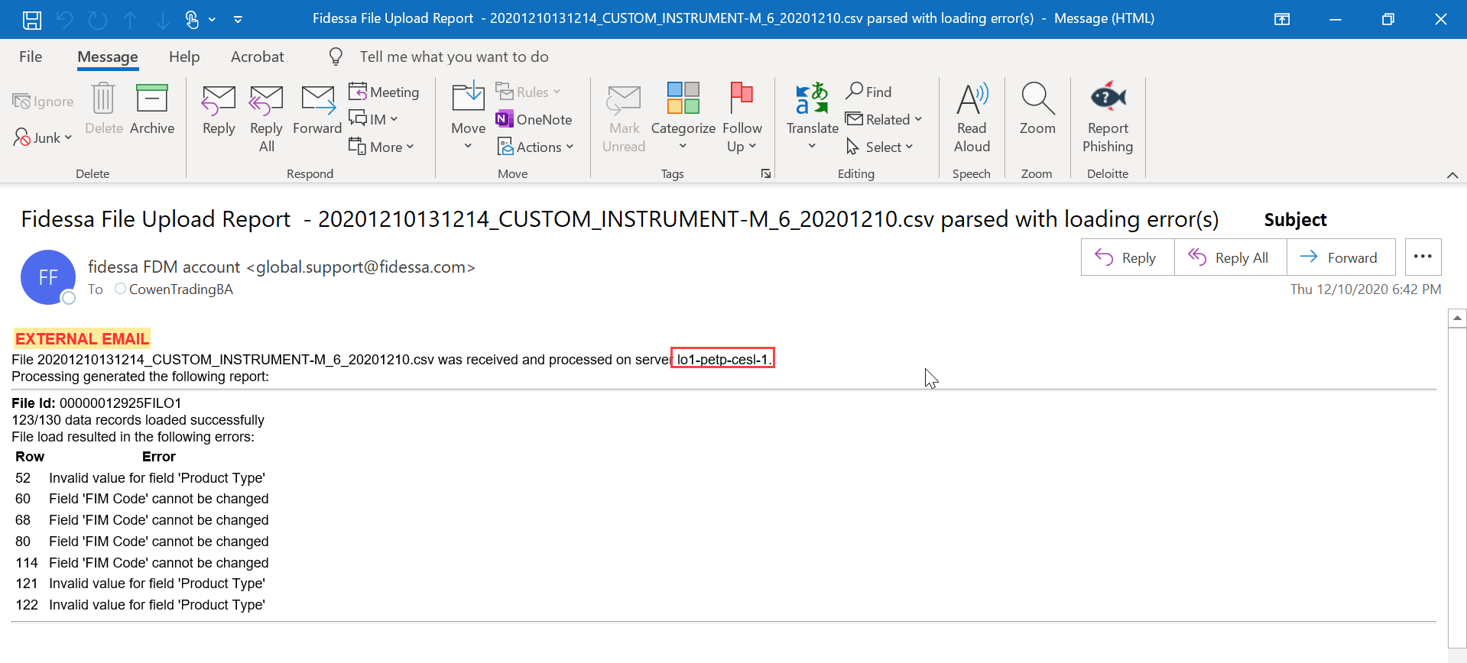

* **File ID:** Copy number after semi colon sign (:) from File ID line in email and paste it in the “File ID” column in Email Summary Dashboard Excel.

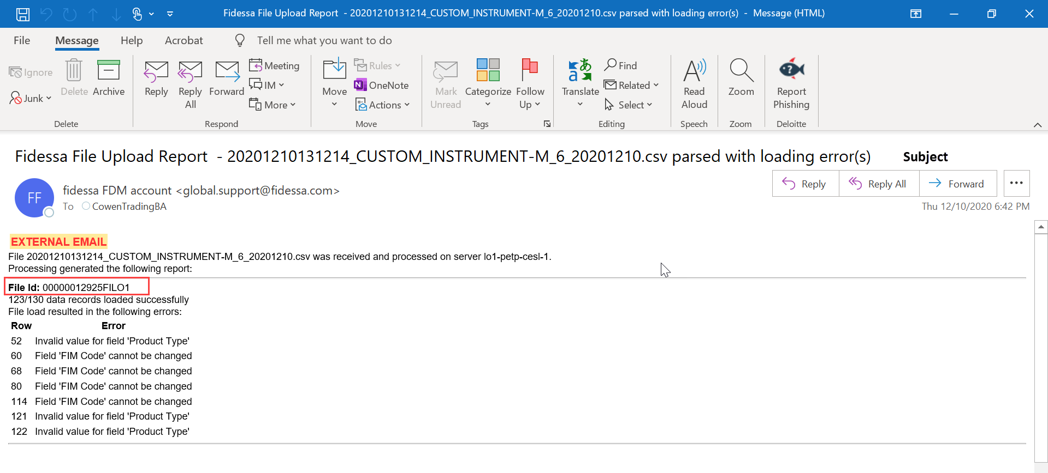

* **Data Records Loaded Successfully:** Copy number before hyphen sign from the line below file ID line and paste it in the “Data Record Loaded Successfully” column of Email Summary Dashboard Excel.
* **Total Data Records:** Copy number after hyphen sign from the line below file ID line and paste it in the “Total Data Record” Successfully” column of Email Summary Dashboard Excel.

**- Refer screenshot below for ”Data Records Loaded Successfully” and ” Total Data Records” (Example 12)**

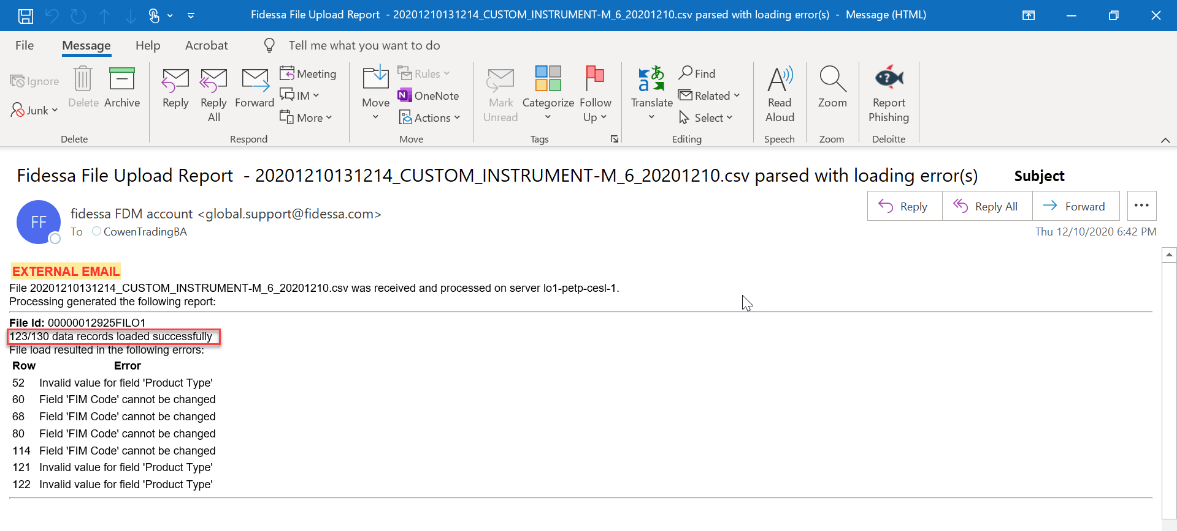

**Note: Repeat the above steps again for the next email under the Inbox, until all the mail’s data are pulled by bot for the dashboard.**

**Changes:**

* “Cowen-Order 3_Restricted Security” email is exactly the same format as the Cowen-Order 2 that we have in scope. The only difference is the sender name and email subject, but the email content is the same. So, we are considering this as in scope
* For raptor instance – Raptor Order Server, Cowen-Order2, Cowen-Order3, Cowen-Order-EURO If subject is loaded successfully as below example.

The COWEN-ORDER2 Raptor server's Security Master loaded successfully

Finished Load - Import File SecMasterGlobal_20210325.psv 25 Mar 2021 05:30:57.608 Security Delta Count 2

Total Records loaded: 314599

Make sure the highlighted number is greater than 310k. If it is not, Bot will alert(**“Alert: Total securities loaded is below specified threshold of 310,000. Please check and confirm this is acceptable” as subject**) and sent back to [support@raptortrading.com](mailto:support@raptortrading.com) for them to look into.

4.3.3 Step-3 - Bot will summarize all the information into SQL database table(TradeProcessMonitor)for respective groups to review

4.3.4 Step 4- Bot will forward certain failure emails (outlined in the “output file” section 3.5) to respective groups for further investigation

**4.3.5 Bot will send a status summary email at 5 PM ET notifying users that it ran successfully.The Bot will move OutofScope & Exception emails to respective OutOfScope, Exception Mailbox.Please note that the bot will notify the users immediately if it encounters any technical and/or business exceptions listed in section 5 “Referrals and Exceptions” below.**

* 1. Service Level Agreements

This section is used to describe if there any Service Level Agreements (SLA’s) for which the business user or process to be executed need to follow.

For this automation, there are no identified SLA’s which would impact the process or which the automation needs to follow.

1. **Referrals and Exceptions**

This section describes the points of handover to a human workforce during the process. Noting that system exceptions – i.e. issues with the target application that mean the virtual worker is unsure how to proceed – are documented in the Solution Design Document (SDD).

3. 1. Human in the Loop Consideration

N/A- There will be no human intervention while the bot is processing.

* 1. Business Exception

|  |  |  |  |
| --- | --- | --- | --- |
| **ID** | **Exception Status** | **Exception Description** | **Exception Handling** |
| **B-001** | Business Exception | Unable to match sender name from the email | Will forward the mail to OutOfScope mailbox |
| **B-002** | Business Exception | Unable to identify the filed name | Will forward the mail to Manual mailbox |
| **B-003** | Business Exception | Unable to read the file format | Send notification to TradeProcessMon@cowen.com immediately and stop the automation from further processing |
| **B-004** | Business Exception | Unable to find EmailSummarySettingFile file | Send notification to TradeProcessMon@cowen.com immediately and stop the automation from further processing |

* 1. Technical Exception

|  |  |  |  |
| --- | --- | --- | --- |
| **ID** | **Exception Status** | **Exception Description** | **Exception Handling** |
| **T-001** | Technical Exception | Unable to access SQL database | Send notification to [IT-EnterpriseCommand@cowen.com](mailto:IT-EnterpriseCommand@cowen.com), [IT-SysAdmin@cowen.com](mailto:IT-SysAdmin@cowen.com) immediately and stop the automation from further processing |
| **T-002** | Technical Exception | Unable to access outlook | Send notification to [IT-EnterpriseCommand@cowen.com](mailto:IT-EnterpriseCommand@cowen.com), [IT-SysAdmin@cowen.com](mailto:IT-SysAdmin@cowen.com) immediately and stop the automation from further processing |
| **T-003** | Technical Exception | Unable to access Excel | Send notification to [IT-EnterpriseCommand@cowen.com](mailto:IT-EnterpriseCommand@cowen.com), [IT-SysAdmin@cowen.com](mailto:IT-SysAdmin@cowen.com) immediately and stop the automation from further processing |
| **T-004** | Technical Exception | Unable to access share drive (\\fileserver01\CowenRPA\Automation\S&T_IT_Dashboard) | Send notification to [IT-EnterpriseCommand@cowen.com](mailto:IT-EnterpriseCommand@cowen.com), [IT-SysAdmin@cowen.com](mailto:IT-SysAdmin@cowen.com) immediately and stop the automation from further processing |
| **T-005** | Technical Exception | Unable to access Config file | Send notification to [IT-EnterpriseCommand@cowen.com](mailto:IT-EnterpriseCommand@cowen.com), [IT-SysAdmin@cowen.com](mailto:IT-SysAdmin@cowen.com) immediately and stop the automation from further processing |
| **T-006** | Technical Exception | Unable to access Notfication file | Send notification to [IT-EnterpriseCommand@cowen.com](mailto:IT-EnterpriseCommand@cowen.com), [IT-SysAdmin@cowen.com](mailto:IT-SysAdmin@cowen.com) immediately and stop the automation from further processing |

1. **Risk Controls**

This section describes whether the scope of automation has an impact on relevant controls or risks as determined by management.

This process is not part of a SOX (Sarbanes-Oxley) control or relevant framework. Further, this process is not part of ICOC (internal control over compliance) and thus, the automated solution will not impact a relevant control framework or create a risk as part of management’s assertions of controls over financial reporting, nor compliance.

The bot logic will ensure information from IT email alerts get logged into Cowen’s database. The automation enhances the process but does not introduce an automated control into a relevant framework.

The automation is hosted on Cowen’s internal Virtual Machine and complies with Cowen’s IT policies and procedures. Neither implementation partner – Deloitte or the automation platform and products provider – UiPath will have access to the information processed by the automation. Refer to section “9. Non-Functional Requirements” for more information.

The scope of the automation only includes accessing and reading data. The automation does not store any of the data processed. Further, all credentials and data process through transactions are encrypted.

1. **Business Continuity**

This section describes the business continuity approach in the events of workforce (physical or virtual) unavailability, systems unavailability, or capacity constraints.

7.1 Physical workforce unavailability

N/A – The scope of the automation does not involve human intervention while the BOT is processing.

7.2 Virtual workforce unavailability

Operational Risk Level for this use case is defined as a 1, meaning the Operate team has up to 24 hours to resolve a technical or business exception. In the event the automation is unavailable, business has the resources identified to manually perform this process in case the bot is down.

7.3 Target application unavailability

The systems in scope for the bot to interact with are:

1. MS Outlook: If this applicaction is unavailable, the BOT will send the exception that it was unable to access MS Outlook to business SME and stop the automation from further processing
2. SQL Database: If the bot is unable to connect with the database, the BOT will send the exception that it was unable to access the DB and stop the automation from further processing.
3. **Change Requests**

The process flow for submitting a change request should proceed as follows:

1. Client requests a change to the process that differs from the PDD that was initially signed off
2. Process Analyst provides high level impact of change to the PDD to provide enough detail to the Architect to determine the impact to the current timeline
3. Analysis of timeline impact is given back to the client to approve the change or not
4. Timeline is updated (if necessary) and additional effort added to affect change

|  |  |  |  |
| --- | --- | --- | --- |
| Change Request Log | | | |
| Request # | **Change Requested** | **Impact to Overall Timeline** | **Approved/Unapproved** |
| 1 |  |  |  |
| 2 |  |  |  |

1. **Non-Functional Requirements**

This section describes whether there are any data privacy concerns or otherwise technical architecture requirements for automations stored within UiPath Orchestrator, for determining how each BOT may be assigned, or available to perform other processes (for example, if a BOT is down, would this BOT be available to perform as a backup).

Based upon the architecture of the Cowen’s UiPath configuration, each BOT will be provisioned separate accounts at the network, domain, application and database layer. There are no restrictions on whether or not available BOT’s can execute this automation.

Note that the term “BOT” is considered the digital worker as housed in UiPath Orchestrator that is available to perform any number of “automations” or otherwise processes. A digital worker or “BOT” is obtained through either an attended or unattended license from UiPath which can execute any automation or process, so long as there are no restrictions within Orchestrator. Thus, any number of “BOTs” or “digital workers” that are available, connected and licensed in UiPath Orchestrator can run any number of automations or processes.